Work documents
DRAFT VERSION
October 11
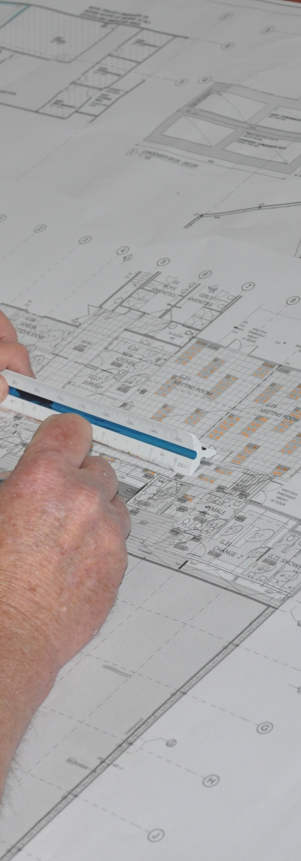
Supporting:
LMFGN3001B: Read and interpret work documents
Workbook
Name:

Work documents
Workbook

Containing learning activities and assignments for the unit of competency:
LMFGN3001B: Read and interpret work documents

The assignment templates are also available in an electronic ‘Word’ version, downloadable from the Kitchen and Bathroom Cabinetmaking website at:
www.kbcabinetmaking.com.au

Developed by Workspace Training for the 2013-2014
Workplace English Language and Literacy (WELL) Program
Flooring Technology resource development project

ISBN: 978-1-925087-09-3
Funded under the Workplace English Language and Literacy Program by the Australian Government through the Department of Industry.
© Commonwealth of Australia 2014

CC BY-NC-SA

This work is copyright. Except where otherwise indicated, and save for the Commonwealth Coat of Arms, the Department has applied the Creative Commons Attribution-Noncommercial-Share Alike 3.0 Australia Licence to this work.
The Department of Industry must be attributed as the author of the Department’s copyright material.
As far as practicable, material for which the copyright is owned by a third party has been clearly labelled. The Department has made all reasonable efforts to ensure that this material has been reproduced in the print-based resources and accompanying website with the full consent of the copyright owners.
Requests and enquiries concerning the Department’s copyright material should be emailed to: media@innovation.gov.au
Questions about the design and content of the resource itself should be addressed to the project manager:
David McElvenny
Workspace Training
PO Box 1954 Strawberry Hills, NSW, 2012
Email: david@workspacetraining.com.au

Table of contents
Introduction 1
Part 1 Learning activities 3
Section 1: Working drawings 5
Section 2: Other documents 9
Part 2 Assignments 11
Assignment 1 13
Assignment 2 15

Introduction
Work documents is a ‘learning unit’ from the Kitchen and Bathroom Cabinetmaking WELL project. It supports the following competency from LMF32109 Certificate III in Cabinet Making (Kitchens and Bathrooms):
- LMFGN3001B: Read and interpret work documents
To be assessed as competent, your assessor will use a range of methods to check your understanding of the concepts presented in the Learner guide for this unit and your ability to apply these principles at work.
These may include:
- written assignments
- practical demonstrations
- on-the-job discussions about how you go about particular activities
- learning activities undertaken while you’re progressing through the unit
- log book or work diary.

Literacy, numeracy and computer skills
Literacy is the ability to read and write. To complete this qualification, you will need sufficient literacy skills to produce a range of workplace documents. You will also need the skills to be able to read and understand documents such as order forms, installation instructions, project briefs and safe operating procedures.
Numeracy is the ability to work with numbers. Kitchen and bathroom installers need to do lots of measure-ups and calculations, so there will be many opportunities for you to learn and practise your numeracy skills.
When it comes to completing the written assignments for this qualification, a certain level of literacy ability is required to read the questions and write down your answers. There will also be times when you are asked to generate documents on a computer.
Obviously, it’s important that you clearly understand what the assignment is asking you to do, and that your work is a good reflection of what you really know. So if you’re having trouble reading the questions, writing down your answers, or using certain computer programs, make sure you speak to your trainer before you hand the assignment in.
There are various ways your trainer can help you. For example, they may be able to ask the assignment questions verbally and help you to write down your answers. They may also be able to show you sample answers to similar questions, which will let you look at the way they’re written and give you hints on how to write your own. You may also be allowed to do the assignment with the assistance of another person.

Applying for RPL
RPL stands for Recognition of Prior Learning. It is a form of assessment that acknowledges the skills and knowledge you have gained through:
- on-the-job experience
- formal training in other courses
- life experience, through your hobbies or other outside activities.
If you believe that you are already competent in some or all of the skills covered in this unit, ask your assessor about how to apply for RPL.

Using this workbook
All of the lessons in the Learner guide for this unit have learning activities at the end. Their purpose is to provide discussion points and questions to help reinforce your understanding of the concepts being presented.
There are also a range of assignments, which appear at the end of each section. These are designed to test your knowledge of the subject matter and ability to submit written responses in an acceptable format.
This workbook reproduces all of the learning activities and assignments in a format that lets you handwrite your answers to the questions.
Note that your trainer may ask you to produce a computer-generated document for all of the formal assignments, either printed out in hard copy or submitted electronically. To do this, go to the website version of the unit and look for the Assignment link in each section. This will allow you to type your answers into the ‘Word’ document and then either print it out or email it direct to your trainer as an attachment.
You may also be asked to share your learning activity answers electronically, especially if you are undertaking this unit by distance learning and are linked up with fellow students in other locations. This might be done through group emails or via a social networking site such as Facebook. In these cases, you should use the website resource rather than this workbook.

Part 1

Learning activities

Section 1: Working drawings

Building plans
Below is the South Elevation of the house that we looked at in the plans in the Learner guide. The numbers along the roof indicate the different rooms across the back of the house.
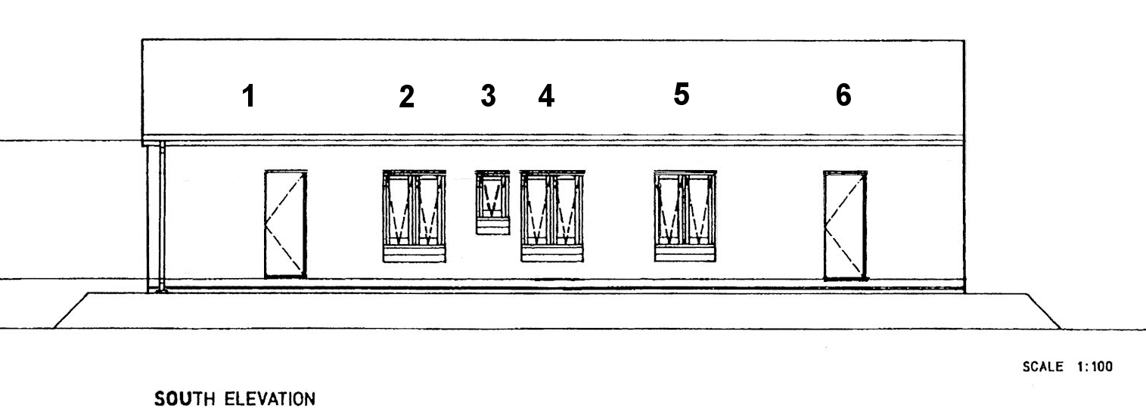
Use the floor plan on page 7 of the Learner guide to identify the rooms that correspond to these numbers. Write your answers in the table below.

Number | Corresponding room
1
2
3
4
5
6

Architectural conventions
The drawings below show a rear elevation and 3D view of a kitchen project. Use a separate sheet of paper to do a simple sketch of the floor plan, using only these two drawings as a guide. There is no need to mark in the dimensions, but try to draw to scale as accurately as possible.
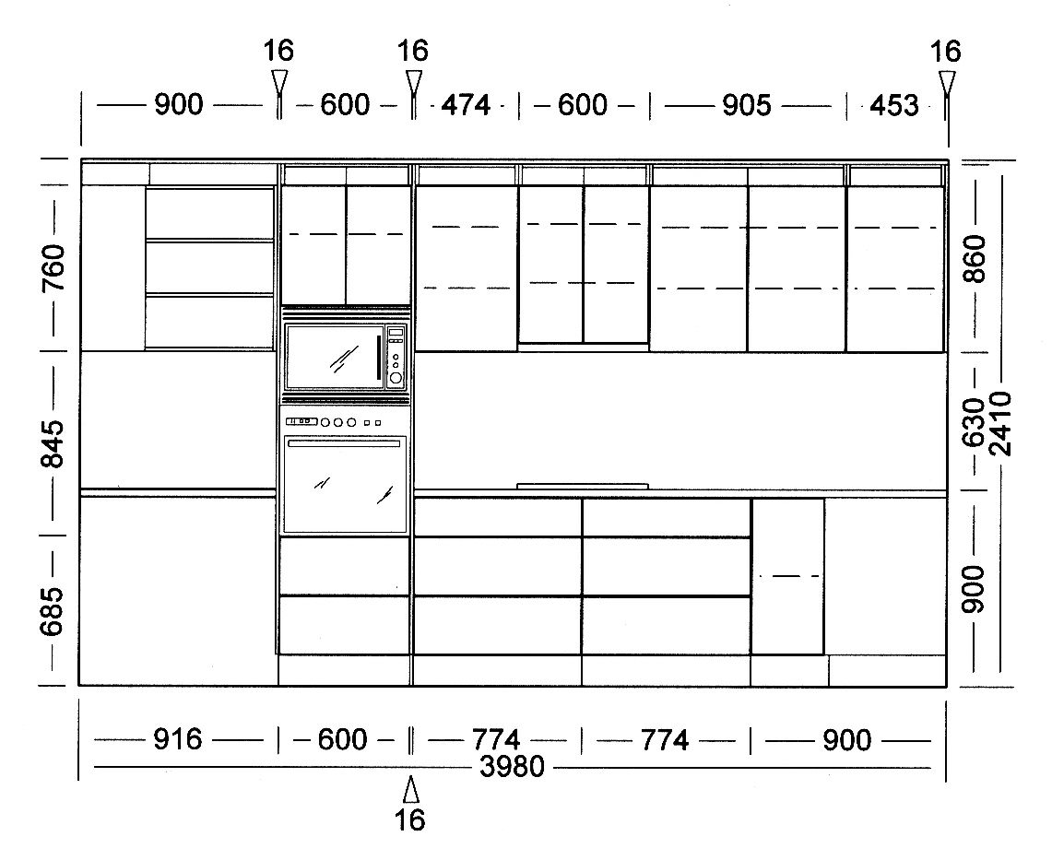
When you have finished, go back to page 7 of the Learner guide to see how your drawing compares with the original floor plan.

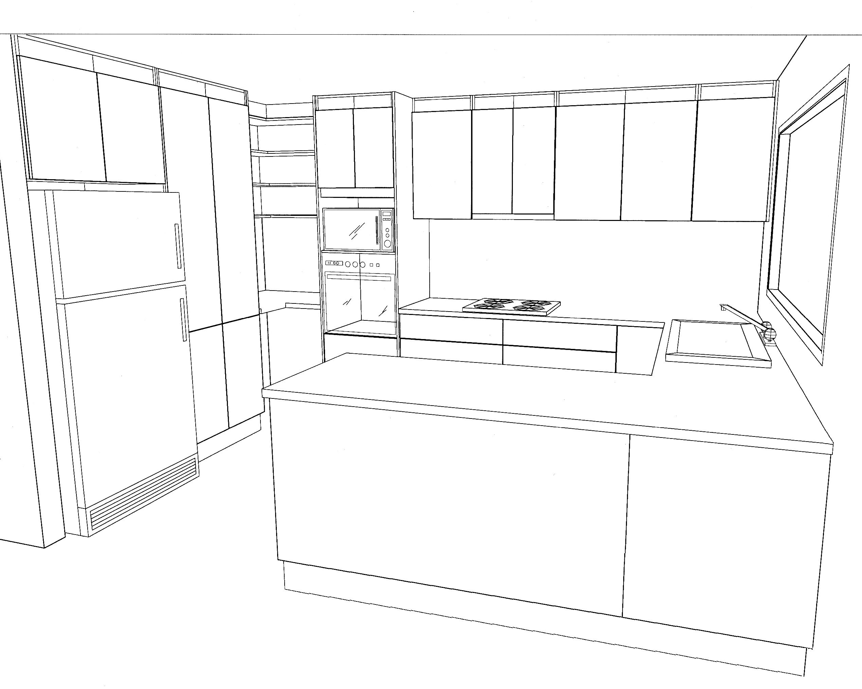

Key information on plans
Below is an excerpt from the floor plan we looked at on page 7 in the Learner guide.
Write out the full name for each of the abbreviations listed in the table underneath the plan. Try to do this task without referring to the abbreviation list in the Learner guide. If you get stuck on any of the abbreviations, you may refer to the list once you’ve finished writing in the answers you know.
Abbreviation | Meaning | Abbreviation | Meaning
FW |  | R
S |  | WC
WM |  | WR

Installation plans
On-site installers are generally given various supporting documents along with the installation plans for a project before they go out to the jobsite.
These may include a list of fixtures and fittings and a final inspection checklist.
What project documentation does your company give to the on-site installers? Make up a list. Try to use the correct title for each document you name.
Document name

Section 2: Other documents

Standards and specifications
Which documents do you need to refer to in your day-to-day work that relate to standards, specifications or manufacturer’s instructions? Write down a list of their titles. Beside each one, briefly describe what you use the document for.
Document name | Purpose

Work procedures
List any documents you use at work that haven’t been discussed in this lesson. Beside each one, briefly describe the purpose of the document.
Document name | Purpose

Planning and checking
Have you ever found a discrepancy between two documents, or seen something that looked like a mistake in a plan or specification? What were the circumstances? Who did you check with to resolve the problem?
If you haven’t had this experience, describe what you would do if you found a problem in the plans or specifications you were working with.

Maintaining files
Are you responsible for filling in particular documents at work? What are they?
Name each document and briefly describe its purpose and where you store it when it’s not being used.
Document name | Purpose | Where stored

Part 2

Assignments

Assignment 1
Your trainer will give you a set of plans for a floor covering project. You will be asked to find the answers to a range of questions about the project by referring to the plans.
The questions will cover the following details:
- dimensions of specific rooms
- widths of doorways and other openings
- which way the doors swing (that is, which side the hinges are on)
- structure of the walls and floor
- various details relating to the cabinets and benchtops.

Assignment 2

Name |  | Date
List 10 different types of documents that you use at work. There must be at least one example of each of the following documents:
- Australian Standard
- manufacturer’s installation guidelines or technical manual
- material safety data sheet
- work plan, project schedule or equivalent
- building code or project specification
- safe operating procedure or equivalent
- safe work method statement, job safety analysis or equivalent
For each of the documents you have chosen, answer the following questions:
- What is the full title of the document?
- What is its purpose?
- Who is responsible for looking after it and making sure the employees are using the latest version? (Give the job title of the person, not their name.)
- What is the version control system – that is, how do you know you’re looking at the latest version?
- Where is it kept at your workplace, and if there are multiple copies, who has copies? (Give the job titles of the people who have their own copies.)
- Who would you consult if you were out on-site and had a query about a detail in the document? (Give the job title or role of the person you would consult.)
Use the tables on the following pages to complete your answers.
Document 1
Title
Purpose
Person responsible
Version control
Where kept / who has copies
Who to consult

Document 2
Title
Purpose
Person responsible
Version control
Where kept / who has copies
Who to consult

Document 3
Title
Purpose
Person responsible
Version control
Where kept / who has copies
Who to consult

Document 4
Title
Purpose
Person responsible
Version control
Where kept / who has copies
Who to consult

Document 5
Title
Purpose
Person responsible
Version control
Where kept / who has copies
Who to consult

Document 6
Title
Purpose
Person responsible
Version control
Where kept / who has copies
Who to consult

Document 7
Title
Purpose
Person responsible
Version control
Where kept / who has copies
Who to consult

Document 8
Title
Purpose
Person responsible
Version control
Where kept / who has copies
Who to consult

Document 9
Title
Purpose
Person responsible
Version control
Where kept / who has copies
Who to consult

Document 10
Title
Purpose
Person responsible
Version control
Where kept / who has copies
Who to consult

