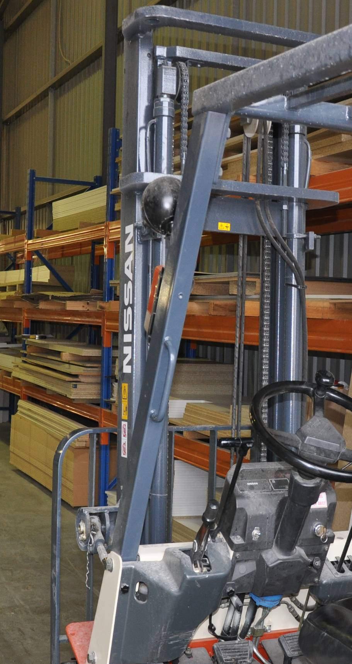

**Supporting:**

***MSAENV272B   
Participate in environmentally sustainable work practices***

Working sustainably

**Learner guide**

**Developed in 2011-2012 for the WELL Program**

DRAFT VERSION

October 11

Working sustainably

Learner Guide

This unit is also available in an e-learning format, which contains additional photos, interactive exercises and a voice-over narration of the text. It can be viewed on CD-ROM, or live on the web at:

<http://www.kbcabinetmaking.com.au/>



Developed by Workspace Training for the 2011-2012

Workplace English Language and Literacy (WELL) Program

Kitchen and Bathroom Cabinetmaking resource development project



[www.workspacetraining.com.au](http://www.workspacetraining.com.au)

ISBN: 978-0-9873328-2-0

Funded under the Workplace English Language and Literacy Program by the Australian Government through the Department of Education, Employment and Workplace Relations.

COPYRIGHT

© Commonwealth of Australia. 2012



***CC BY-NC-SA***

This work is copyright. Except where otherwise indicated, and save for the Commonwealth Coat of Arms, the Department has applied the Creative Commons Attribution-Noncommercial-Share Alike 3.0 Australia Licence to this work.

The Department of Education, Employment and Workplace Relations must be attributed as the author of the Department’s copyright material.

As far as practicable, material for which the copyright is owned by a third party has been clearly labelled. The Department has made all reasonable efforts to ensure that this material has been reproduced in this print-based resource and the accompanying website with the full consent of the copyright owners.

Requests and enquiries concerning the Department’s copyright material should be addressed to:

The Copyright Officer

Department of Education, Employment and Workplace Relations

Location code C148CW2

GPO Box 9880 Canberra ACT 2601

Email: [copyright@deewr.gov.au](mailto:copyright@deewr.gov.au)

Questions about the design and content of the resource itself should be addressed to the project manager:

David McElvenny

Workspace Training

PO Box 1954 Strawberry Hills, NSW, 2012

Email: [david@workspacetraining.com.au](mailto:david@workspacetraining.com.au)

## About this resource

This learner guide is one of 11 learner guides developed for the *Kitchen and Bathroom Cabinetmaking* project, funded by the WELL Program in 2011-2012. The guides are aligned to the following core and elective competencies from the *Certificate III in Cabinetmaking (Kitchens and Bathrooms) LMF32109*:

*LMFKB2001A Prepare for cabinet installation*

*LMFKB3001A Identify processes in kitchen and bathroom*

*LMFKB3002A Determine requirements for installation*

*LMFKB3003A Check and measure fit of cabinets*

*LMFKB3004A Conduct on-site adjustments to cabinets*

*LMFKB3005A Fabricate cabinets for the built-in environment*

*LMFKB3006A Install fitted cabinets and components*

*LMFFM3006B Install furnishing products*

*MSAENV272B Participate in environmentally sustainable work practices*

*MSAPMOHS200A Work safely*

*MSAPMOPS101A Make measurements*

The purpose of the guides is to help apprentice cabinetmakers acquire the background knowledge needed to satisfy the theoretical components of these units. However, they are not designed to replace the practical training necessary to develop the hands-on skills required. Learners will still need to receive extensive on-the-job training and supervision before they will be ready to be formally assessed in these units.

### E-learning version

All of these units are also available in an e-learning format, which contains additional photos, interactive exercises and a voice-over narration of the text. The   
e-learning version can be viewed live on the web at:

<http://www.kbcabinetmaking.com.au/>

The web version can also be purchased on a CD at a cost-recovery price from the project developer:

David McElvenny (project manager)

Workspace Training

PO Box 1954 Strawberry Hills, NSW, 2012

Email: [david@workspacetraining.com.au](mailto:david@workspacetraining.com.au)

## Acknowledgements and disclaimer

### Project team

Project manager: David McElvenny

Instructional design: Kath Ware

Technical developer (website): Jim Vaughan

Assistant technical developer (and voice-over artist): Alex Vaughan

Quality assurance consultant: Giselle Mawer

Industry coordinator: Gary Dunshea (MSA Industry Skills Council)

Lead advisor: Rob Cole (Furnishing Industry Association of Australia)

### Technical Advisory Group

**New South Wales**

Brad Holmes – Hunter TAFE

Grant Cohen – Hunter TAFE

Dean Brakell – Furnishing Industry Association of Australia

Warren Peters – South West Sydney Institute of TAFE

Sean Greening – South West Sydney Institute of TAFE

**ACT**

Martin Jud – Canberra Institute of Technology

**Victoria**

Bryon Stanley – Furnishing Teacher's Advisory Group (VIC, SA, TAS)

Richard Brooks – Cabinet Makers Association

Simon Hampton – Wodonga TAFE

John Simpson – Holmesglen TAFE

**Tasmania**

Stephen Kirkman – Skills Institute Tasmania

**Queensland**

Rob McAdam – Skills TECH Australia

Brad Buhse – Skills TECH Australia

Roberto Viola – Gold Coast Institute of TAFE

**South Australia**

John Holst – Marleston TAFE

Dean Hart – Mt Gambier TAFE

Martin Videon – Furnishing Industry Association of Australia

**Northern Territory**

Hermann Oltrop – Charles Darwin University

**Western Australia**

Garry Michels – Polytechnic West

Keith Campbell – Polytechnic West

Adrian Boyling – Polytechnic West

David Boaden – Polytechnic West

Lorenzo Procopio – South West Institute of Technology

**National**

Laurie Kruize – Housing Industry Association

### Photographs and graphics

All photos were taken by David McElvenny. All graphics were drawn by Kath Ware. We would like to thank the following companies for allowing us to take photos of their installers and workshop employees and generously providing technical advice:

Canobolas Kitchen Designs Flair Kitchens

Danson’s Kitchens and Joinery Lamtex Innovative Furniture

Fewings Joinery Stateline Cabinets

B&B Joinery Ian McConnell Constructions

Krauss Kitchens

### Financial contributions

This resource was largely funded by the Workplace English Language and Literacy Program, through the Department of Education, Employment and Workplace Relations. However, due to the scale of the project and the provision of print-based and website resources, additional financial assistance was provided by the following organisations:

Manufacturing Skills Australia (Industry Skills Council)

Furnishing Industry Association of Australia

### Disclaimer

The content of this learner guide is provided for educational purposes only. No claim is made as to the accuracy or authenticity of the content. The views expressed in this publication do not necessarily represent the view of the Minister for Education or the Australian Government. The Australian Government does not give any warranty nor accept any liability in relation to the contents of this work.

**Table of contents**

[**Introduction 1**](#_Toc305669722)

[Section 1 Resources used at work 3](#_Toc305669723)

[Overview 5](#_Toc305669724)

[Making a product 6](#_Toc305669725)

[Measuring usage levels 9](#_Toc305669726)

[Assignment 1 11](#_Toc305669727)

[Section 2 Environmental issues at work 13](#_Toc305669728)

[Overview 15](#_Toc305669729)

[Air quality 16](#_Toc305669730)

[Stormwater 18](#_Toc305669731)

[Trade wastewater 19](#_Toc305669732)

[Hazardous substances 20](#_Toc305669733)

[Laws and procedures 23](#_Toc305669734)

[Assignment 2 24](#_Toc305669735)

[Section 3 Improving efficiency 27](#_Toc305669736)

[Overview 29](#_Toc305669737)

[Using less power 30](#_Toc305669738)

[Using less water 31](#_Toc305669739)

[Managing waste 32](#_Toc305669740)

[Assignment 3 34](#_Toc305669741)

|  |
| --- |
| Introduction |

What is the **environment**? Some people think of it as the whole of nature – in other words, the entire planet. Other people think of it as just their immediate surroundings. The fact is, it’s both. The environment is everywhere, which is why things that happen in one place can have such a significant effect somewhere else.

What does it mean to work in an **environmentally sustainable** way? Basically, it’s all about employing work practices that use up less natural resources and produce the minimum amount of waste and pollution. The aim is to make sure that our activities don’t hurt the ability of future generations to meet their own needs and enjoy a good quality of life.

In this unit, we’ll look at some of the work practices that can have a negative effect on the environment, and suggest ways of improving the way they’re carried out. We’ll also examine the regulations that apply to environmental care, and how these translate into your own work processes. And we’ll discuss methods you can use to look for improvements in the environmental care practices you follow at work.

### Working through this unit

There are three sections in this unit:

* Resources used at work
* Environmental issues at work
* Improving efficiency

Each section contains an *Overview*, an *Assignment*, and several *Lessons* which cover the content material. Your trainer may ask you to submit the assignments as part of your assessment evidence for the unit. You will find hard-copy templates for these assignments in the separate workbook.

Electronic ‘Word’ versions of the assignment templates are available on the website for this resource, at: <http://www.kbcabinetmaking.com.au/>

The electronic versions can be completed on-screen and sent to the trainer either as:

* a printed hard copy, mailed through the post
* an electronic file, emailed as an attachment.

### Additional material

Although this Learner Guide has been developed as part of the kitchen and bathroom cabinetmaking project, it has general relevance to a wide range of qualifications in the manufacturing industries.

For more specific coverage of sustainability issues relating to kitchens and bathrooms, see the two publications shown below. These manuals provide guidelines on the using sustainable materials, identifying environmentally unfriendly materials, designing cabinets for sustainability, reducing energy consumption and waste, and strategies on offering customers a ‘green’ choice.

You can access these publications by going to the *kbcabinetmaking* website, and clicking on the *Supporting resources* link in the side menu bar. They are available for download as PDF documents.

* *Sustainability in the manufacturing of kitchen and bathroom cabinets,*   
  Mark McDonald (published by the International Specialised Skills Institute)
* *Sustainability in kitchen and bathroom cabinet manufacturing,*Mark McDonald(astudent learner guide version of the above publication, adapted for the Gordon Institute of TAFE).

# DSC_0125

# Section 1

# Resources used at

# work

|  |
| --- |
| Overview |

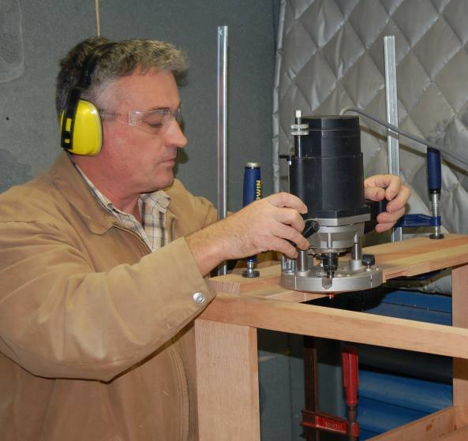A **resource** is any material or energy source that goes into producing an item or achieving some other outcome.

Every business uses resources, and businesses involved in manufacturing use more than most. This is because the process of making a product not only consumes natural resources, it also requires energy to power the manufacturing process itself.

On top of that, there are many other resources needed to carry out the activities that surround the manufacturing process, such as transportation, packaging and cleaning.

Taking a step further back again, there are thousands of other resources involved in providing the infrastructure that makes the whole process possible, such as the production machinery, the factory that houses the machinery, and all the administrative services that support the operation.

### Completing this section

The assignment for this section is designed to help you identify the types of resources you use and to measure their quantities. Have a look at *Assignment 1* on page 11 to see what you’ll need to do to complete it.

There are also two lessons for this section:

* *Making a product*
* *Measuring usage levels.*

These lessons will provide you with background information and worked examples relevant to the assignment.

|  |
| --- |
| Making a product |

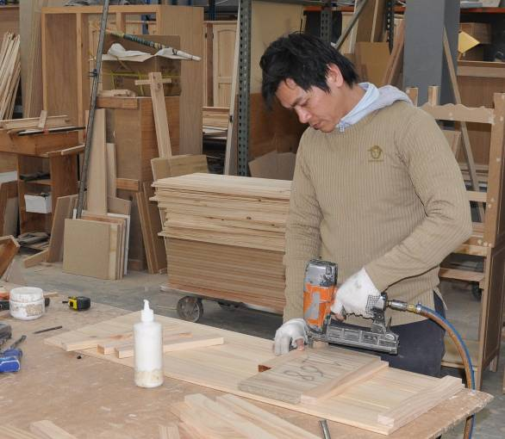Manufacturing is all about making things out of materials. In most cases, the final product is made up of a combination of raw materials and pre-manufactured items. Whatever the items and materials are, all of them will ultimately have come from natural resources.

But in addition to these physical items that you can see and touch, there are countless other resources used to provide the energy and system of operation that allows you to carry out the manufacturing process.

Let’s look at a specific example.

### An example

Just say you were asked to build a solid timber chest of drawers for a client. Below is a breakdown of resources and materials that might be used up in the process of manufacturing the product:

**Materials and items contained in the finished product:**

* timber for the drawers and outer cabinet
* medium density fibreboard (MDF) in the drawer bases and the unit’s backing
* steel and plastic drawer runners
* steel drawer handles
* steel staples for fixing the unit together
* polyvinylchloride (PVC) glue in the joints

**Other ‘consumable’ items used in the manufacturing process:**

* drill bits, router bits and saw blades used to machine the timber
* sandpaper to sand down the timber
* cloths and solvents to dust off and clean the item and equipment during manufacture.

**‘Process’ energy used directly in the manufacturing process:**

* electricity to power the drills, routers, saws and other machining equipment
* compressed air to power the staple gun and spray gun.
* ‘Non-process’ energy used in the activities that support the manufacturing process:
* electricity to power factory lighting, computers, appliances and other facilities
* fuel to power delivery trucks
* gas to power forklift trucks.

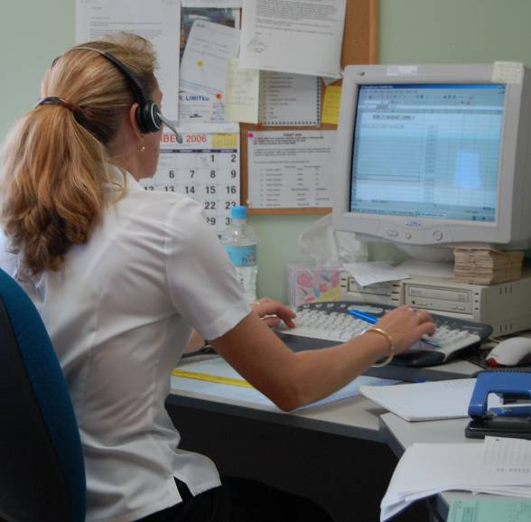You can see from the lists above that we are already getting a very big collection of materials and energy sources, and we haven’t even started on the resources used by administrative and sales staff.

And it doesn’t stop there – once the drawers are finished, there are many other resources needed to get it from the factory to the store or warehouse, and finally to the purchaser’s home.

But for the purposes of our example, let’s stay with the immediate materials and energy sources needed to make the product, and trace each of them back  
 to the basic resources that came from the natural environment.

### Natural resources

See the tables below for the natural resources used in each of the elements required to manufacture the chest of drawers.

|  |  |
| --- | --- |
| **Materials and items** | **Natural resources used** |
| Timber (for the main structure) | Solid wood from trees |
| MDF (for backing and drawer bases) | Wood fibres from trees  Gases and chemicals (formaldehyde glue) |
| Drawer handles (steel) | Iron ore and other mineral additives |
| Drawer runners (steel and plastic) | Iron ore and other mineral additives (steel)  Petroleum (plastic) |
| Staples (steel) | Iron ore and other mineral additives |
| PVA glue | Crude oil and chemical additives |

|  |  |
| --- | --- |
| **Other consumables** | **Natural resources used** |
| Drill bits, router bits, saw blades | Iron ore and other mineral additives |
| Sandpaper | Sand and wood |
| Cloths (for cleaning) | Cotton |
| Solvents | Natural oils or crude, plus additives |

|  |  |
| --- | --- |
| **‘Process’ energy** | **Natural resources used** |
| Electricity (for machinery) | Mostly coal, plus water |
| Compressed air (from compressor) | As above (electricity to power motor) |

|  |  |
| --- | --- |
| **‘Non-process’ energy** | **Natural resources used** |
| Electricity (used throughout factory) | Mostly coal, plus water |
| Fuel (petrol and diesel for vehicles) | Crude oil plus additives |
| Gas (for forklift trucks) | Natural gas |

|  |
| --- |
| Measuring usage levels |

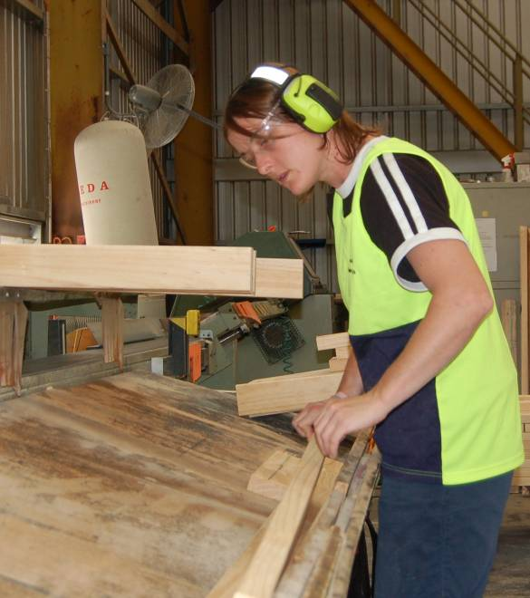Working sustainably is all about making the most efficient use of natural resources, and producing the least amount of waste and pollution possible. But before you can look for ways of improving efficiency, you need to have some idea of your **current resource usage**.

This gives you a benchmark to compare any improvements against. It also allows you to see how much you are saving, and which production methods work best and are the most economical.

It’s not always easy to measure all the resources you use, especially when some of them aren’t directly visible. For example, electricity consumption is hard to quantify unless you can put a power meter on every electrical item used in the job.

Usage levels are also hard to pin down if only a small proportion of a resource is used in the manufacture of one item – such as water for cooling or cutters for planing. However, there are still ways of measuring the usage of various resources, so that you can make comparisons between the quantities being consumed over time.

### Resource usage measurements for a chest of drawers

Let’s see how we could quantify the materials and energy supplies that go into making the solid timber chest of drawers we looked at in the last lesson (Making a product). The tables below show the list of resources we’ve identified for this item, together with their units of measurement and typical quantities used.

|  |  |  |
| --- | --- | --- |
| **Material or item** | **Unit of measurement** | **Quantity used** |
| Timber | Size (cross section) and lineal metres (l/m) | 190 x 19: 3.6 l/m (drawer fronts) 140 x 12: 3.3 l/m (drawer sides) 400 x 19: 4.2 l/m (cabinet) 42 x 19: 6.6 l/m (internal) |
| MDF | Sheet size, thickness and number | 1800 x 1200 x 3 mm 1 sheet |
| Drawer runners | Size and number | 350 mm: 4 left hand; 4 right hand |
| Staples | Size and number | 45 mm: 50 staples |
| PVC glue | Volume (ml) | 20 ml |

|  |  |  |
| --- | --- | --- |
| **Other consumables** | **Unit of measure** | **Quantity used** |
| Drill bit | Size and number | 6 mm: 1/50th \* |
| Router bit | Size, profile, number | 20 mm, ovolo profile, 1/30th \* |
| Saw blade | Size and number | 300 mm, 1/300th \* |
| Sandpaper | Grade, size, number | 180 grit, 150 mm disc, 3 sheets |
| Cloths | Size and number | 400 x 300 mm, 1/5th \* |
| Solvent | Millilitres (ml) | 10 m/l |

\* fraction represents the number of units (chests of drawers) that can be manufactured before this item needs to be replaced.

|  |  |  |
| --- | --- | --- |
| **Process energy** | **Unit of measure** | **Duration of use** |
| Electricity | Operational time | Power drill: 30 secs Router: 2 min 30 secs Docking saw: 4 min 20 secs Orbital sander: 12 mins |
| Compressed air | Operational time | Staple gun: 30 secs |

For the sake of the exercise, we won’t look at the details of the **Non-process energy** usage. However, at a management level, these forms of energy consumption are generally examined in close detail, because they can have a significant effect on the overall running costs of the company.

We will look at practical ways of reducing energy consumption in more detail in Section 3: *Improving efficiency*.

|  |
| --- |
| Assignment 1 |

**Question 1: Identifying resource usage**

Choose a product that you manufacture at work. Think about the types of resources that go into its construction and then answer the questions below.

1. Describe the product.

2. (a) What materials and other items are contained in the finished product?

(b) Which natural resources do these materials and other items come from?

3. (a) What other consumable items are used in the manufacturing process?

(b) Which natural resources do these consumables come from?

4. (a) What are the ‘process’ energy requirements for constructing this product?

(b) Which natural resources are needed to provide these energy requirements?

5. (a) What are the ‘non-process’ energy requirements for manufacturing this product

(b) Which natural resources are needed to provide these energy requirements?

To see a worked example for this question, go to the lesson: **Making a product**.

**Question 2: Measuring resource usage**

Write down the quantities of the materials, items and other consumables that go directly into the finished product. Also specify the unit of measurement you have used to quantify the amounts.

To see a worked example for this question, go to the lesson: **Measuring usage levels**.

**Completing this assignment**

You will find a hard-copy template for this assignment in your Workbook. There is also an electronic version of the template on the website. See the *Introduction* (page 1) for more details on how to access this file.

# DSC_0125

# Section 2

# Environmental

# issues

# at

# work

|  |
| --- |
| Overview |

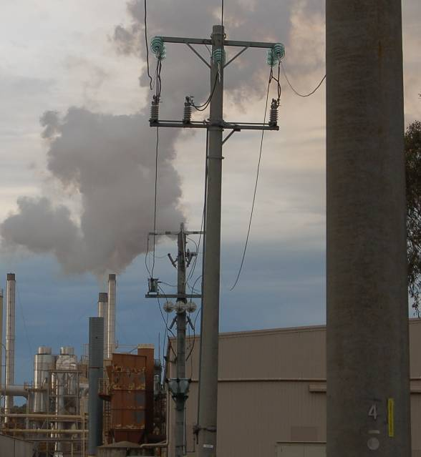Over the last few years, environmental controls and regulations have become increasingly strict. This reflects the growing understanding that we need to be more careful about the resources we use and the wastes and pollution we produce. Communities have realised that if we don’t take more care, the way we live and go about our business can have an incredibly damaging effect on the natural world around us.

In this section, we’ll look at the main environmental issues that concern businesses involved in manufacturing. We’ll also discuss the effect that new laws and regulations have on the way a business operates, and the obligations they impose on employees as they carry out their day-to-day work.

### Completing this section

The assignment for this section will ask you to examine a range of environmental protection issues at your own workplace. Have a look at *Assignment 2* on page 24 to see what you’ll need to do to complete it.

There are five lessons for this section:

* *Air quality*
* *Stormwater*
* *Trade wastewater*
* *Hazardous substances*
* *Laws and procedures*

These lessons will provide you with background information relevant to the assignment.

|  |
| --- |
| Air quality |

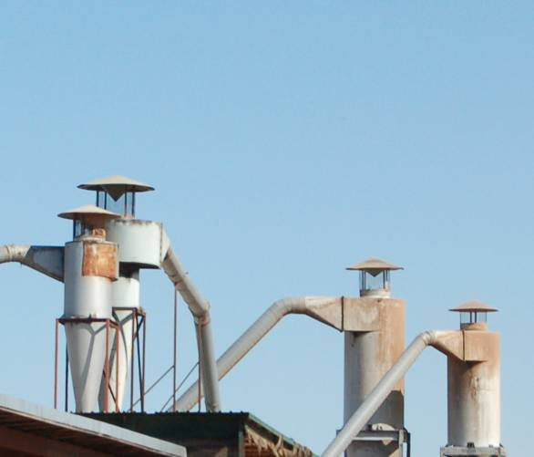Clean air is something that most people take for granted. But in a manufacturing workplace there are many contaminants that can pollute the air through industrial processes or other activities.

### Volatile organic compounds

Volatile organic compounds (VOCs) are chemicals that can evaporate into the air and cause serious environmental problems and chronic health conditions. They include formaldehyde, paints, protective coatings and other solvents.

The best way to limit the amount of evaporation when you’re not using these substances is to keep the containers well sealed.

### Dust

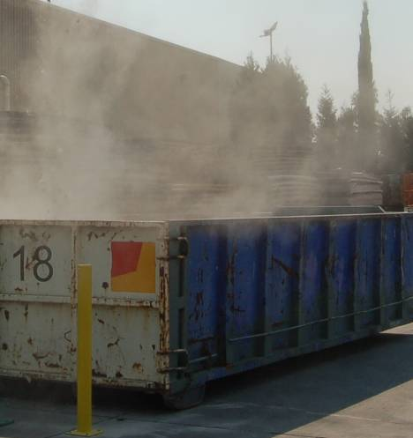One of the most obvious airborne problems is dust. Some types of dust are toxic, particularly if they contain formaldehyde glues or other chemicals. Even common forms of dust can produce fallouts in the neighbourhood. And if people are exposed to them for a long time, they can cause health problems.

There are two main ways of managing dust that is generated in the workplace:

* good housekeeping, and
* collecting the dust as close to its production source as possible.

A dust extraction system is the easiest way to control dust at its source. The equipment can either be connected to a centralised unit, or individual machines can have their own systems. You can also control dust build-up by sweeping or vacuuming the area.

Note that some dusts require the use of personal protective equipment (PPE) while you’re exposed to it. If you’re not sure whether you need to wear PPE, ask your supervisor before you begin to clean it up.

### Burning

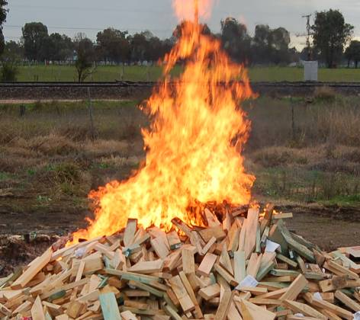Burning off waste products or rubbish can cause serious air pollution, especially when the waste contains plastics or other chemical compounds. Even ordinary paper and other wood-based products can be responsible for problem emissions and smoke haze.

In general, open air burning is not allowed by local councils, particularly in metropolitan areas, unless you’ve got a permit. Apart from the emissions it creates, open air burning can be a serious fire hazard in the hotter months of the year.

|  |
| --- |
| Stormwater |

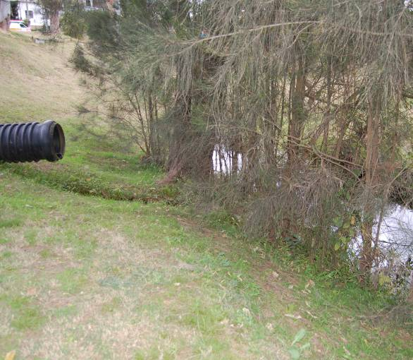Every time it rains at your workplace, the water washes over the outside areas, and either soaks into the ground or disappears down the stormwater drains. These drains generally come out at the local creek or canal, and eventually discharge into a river, harbour or beach.

Unlike sewerage, stormwater isn’t treated to remove any pollutants that are in it. So if it’s contaminated with litter, wastes, grease, oil or other chemicals, these will find their way into the natural environment, where they can have a serious effect on the fish, plants and other life forms living in that ecosystem.

That’s why it’s an offence to allow stormwater to become polluted. This includes placing substances in a position where they can fall or be blown into a local waterway, gutter or drain. It also includes allowing silt to wash into the stormwater and send it murky, or ‘turbid’.

### Simple things you can do

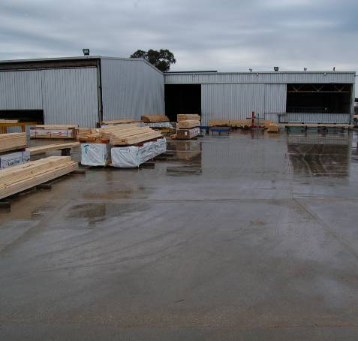There are many simple things you can do on a day-to-day basis to stop rainwater from becoming polluted as it runs off into the stormwater drains. These include:

* making sure that contaminates aren’t allowed to accumulate in areas where they could be washed away by rain, especially near drains
* keeping driveways and yard areas free of litter
* providing containers for cigarette butts
* keeping drains clear, to allow the free flow of water when it rains.

|  |
| --- |
| Trade wastewater |

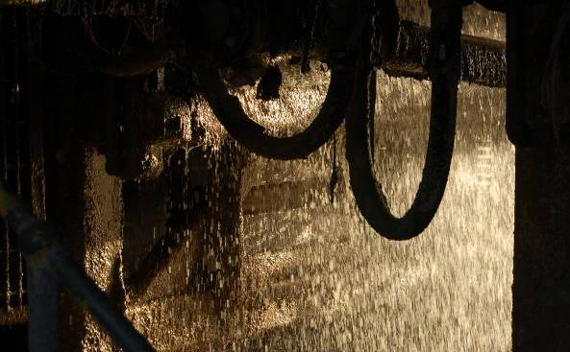Trade wastewater is any wastewater produced by a commercial or industrial activity. It doesn’t include sewerage from toilets or sinks, but does include the run-off from industrial sprays and cooling systems.

Wastewater isn’t always toxic, but even non-toxic wastewater can be harmful if it’s put straight into the sewer without the problem substances being removed first.

Before you let wastewater go into the sewerage system, you need to remove the contaminants, and your company needs to get a wastewater permit from the local water authority. This permit will specify the treatment process required and any other standards that may apply.

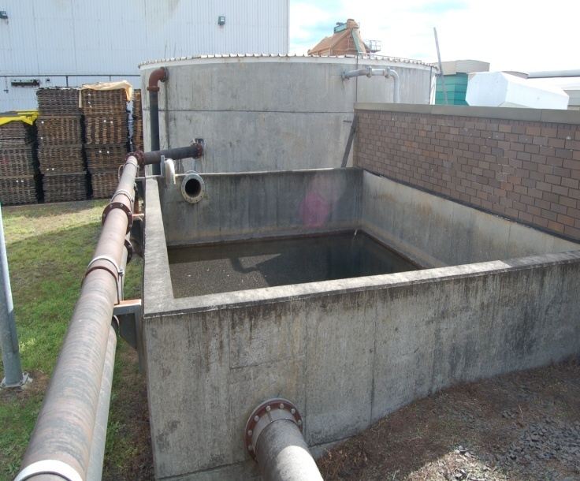But not all businesses need to put their wastewater into the sewerage system. Some companies recycle the wastewater on-site, and treat it so it can be used in other production processes or for watering the garden.

Other companies collect the wastewater in drums, and have it taken to a waste disposal station. But remember that if you’re sending it to a waste facility, the transportation must always be done by a licensed contractor.

|  |
| --- |
| Hazardous substances |

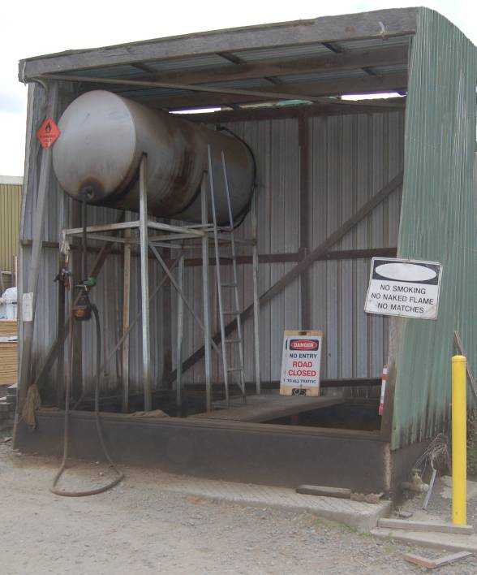Hazardous substancesareany substances that might be harmful to people’s health or cause damage to the environment. They range from common household products like solvents and pesticides through to thousands of other liquids, gases and materials used in workplaces.

Some hazardous substances, such as gas and diesel fuel, are classified as **dangerous goods**. Their storage, transportation and use are controlled by law, because of their potential to cause fires or explosions.

Every hazardous substance is required to have a **material safety data sheet** (MSDS), which is published by the manufacturer of the substance. The MSDS is designed to give you important information on how to use the product safely, how to store it and transport it, and what to do if the substance spills.

You can see an example of a typical MSDS summary on page 19. This is a condensed version of a full MSDS.

Dealing with spills

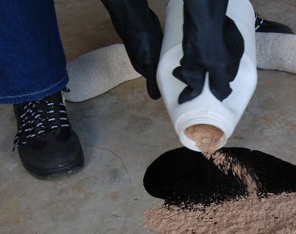Spills can be a real problem when they involve a hazardous substance. They should always be cleaned up straight away, no matter how small they are. Quite apart from any safety risks involved, you don’t want the spill to escape into the stormwater system or soak into the ground and cause contamination.

If you have a serious spill at your workplace, or if you’re worried about safety, call the fire brigade on 000.

Note that if a spill occurs that might harm the environment, you must tell the Environment Protection Authority (EPA) or local council as soon as you become aware of it.

### General guidelines on handling and storage

Here’s some general guidelines to follow when you’re handling or storing hazardous substances.

1. 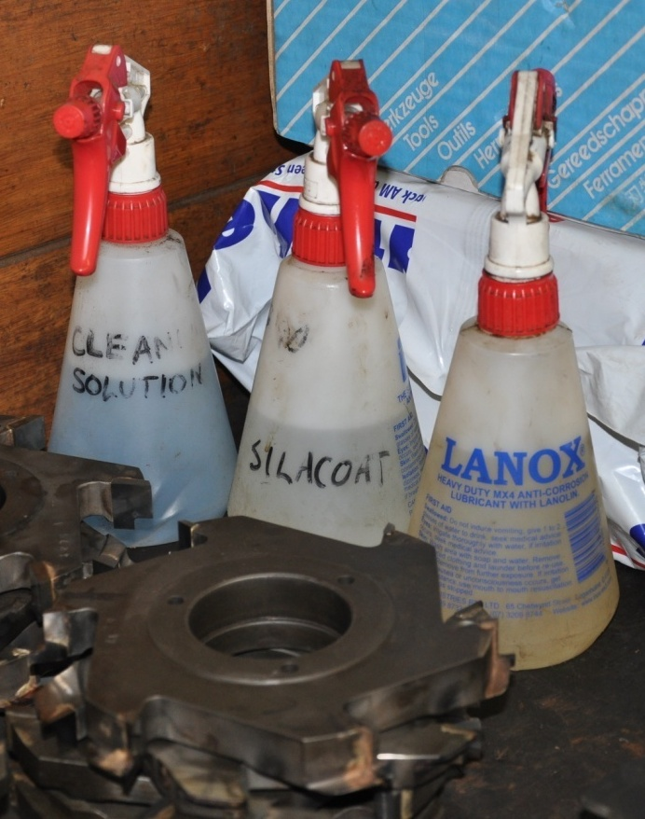Store chemicals in their own area, away from stormwater drains and out of the weather.
2. Never use plain drink bottles or other unmarked containers to store chemicals.
3. Clearly label all containers with the name of the product it contains if it is no longer in its original packaging.
4. Keep ‘incompatible’ chemicals well away from each other, that is, chemicals that are likely to react with each other.
5. Dispose of hazardous waste properly, using a licensed contractor to take it to a licensed   
   depot.
6. Make sure that all vehicle activity is   
   carried out well clear of the chemical   
   storage area.

|  |  |
| --- | --- |
| Material safety data sheet summary for ‘Rapid Coat’ preservative | |
| **Description** | A light organic solvent preservative treatment. |
| **First aid** | Swallowed: do not induce vomiting – give glass of water.  Eye contact: flush with water for 15 mins and contact doctor.  Skin contact: wash with soapy water and remove contaminated clothing.  Inhaled: remove person to fresh air, keep warm and at rest. |
| **Recommended PPE** | Chemical goggles; rubber gloves; respirator with Type A-P filter |
| **Handling precautions** | Keep away from sources of ignition. Use only in a well ventilated area. Do not empty into drains. Keep container tightly closed. |
| **Minor spills** | Remove ignition source. Clean up the spill immediately. Contain small quantities with sand, earth or vermiculite. Collect residues and seal in a labelled container for later disposal. |
| **Major spills** | Evacuate the area and alert the fire brigade. Remove all ignition sources. Wear breathing apparatus and gloves. Prevent spillage from entering drains or water courses. Collect residue and seal in a labelled drum. |
| **Disposal** | Consult the distributor for recycling options. Consult the local waste management authority for disposal information. |
| **Storage and transport** | Classified as: Dangerous Goods Class 3.  Label required: Flammable Liquid.  Store in original container under cool, dry conditions, away from sources of ignition and incompatible chemicals. Keep container sealed. |
| **Flammability** | Class 3 – high flammable.  Extinguish fire with carbon dioxide, dry chemical powder or foam extinguisher. |

|  |
| --- |
| Laws and procedures |

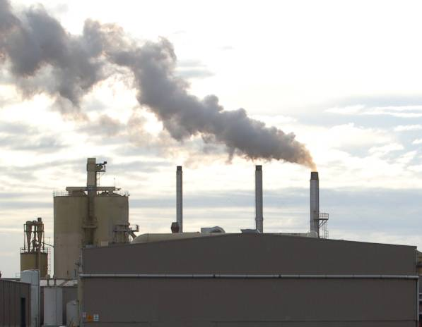In each state the Environment Protection Authority (EPA), or its equivalent body, oversees the laws concerning environmental care. One of their main functions is to regulate the activities of large industries and issue notices if companies do the wrong thing. If the offence is serious enough, they will prosecute the company.

Local councils also play a role in environmental protection, and regulate smaller businesses and industries through planning controls, notices and prosecutions.

### Obligations on employees

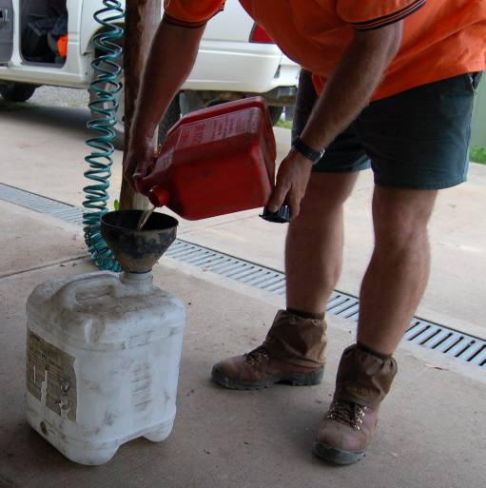Generally speaking, the company you work for will have already built the relevant environmental laws and regulations into the policies and procedures you follow every day at work. But it’s worth keeping in mind that some laws go beyond the obligations placed on the company, and extend directly to all employees and contractors working at the site.

For example, the law states that if pollution occurs when you’re doing something and it threatens or harms the environment, you must tell the EPA or the local council as soon as you can. This allows the authorities to take steps to minimise the impact of the problem before it gets out of hand.

|  |
| --- |
| Assignment 2 |

**Question 1: Controlling air quality**

Name a substance or emission produced at your workplace that would reduce the air quality if it was not properly controlled. Describe the control measures your company takes to manage the problem.

**Question 2: Protecting stormwater**

Name a substance or material at your workplace that could end up polluting the stormwater system if there weren’t measures in place to stop it from happening. Describe the control measures your company takes.

**Question 3: Reading an MSDS**

Choose a Material Safety Data Sheet (MSDS) that relates to a product you use at work. Answer the following questions.

1. What is the trade name or technical name of the product?
2. What is the product used for? Provide a brief description of the product.
3. Where is the MSDS kept that relates to this product?
4. Is there a fire risk with the product? If so, what equipment is required to put out a fire?
5. What should you do in the event of a spill? Describe the clean-up process.
6. How should you dispose of the product?

**Question 4: Following procedures**

1. Give one example of an environmental policy or procedure at your workplace that directly affects the work you do.
2. If there was an environmental incident or problem at your workplace, who would you report it to on-site?
3. When does an incident need to be reported to the Environment Protection Authority?

**Completing this assignment**

You will find a hard-copy template for this assignment in your Workbook. There is also an electronic version of the template on the website. See the *Introduction* (page 1) for more details on how to access this file.



# 

# Section 3

# Improving

# efficiency

|  |
| --- |
| Overview |

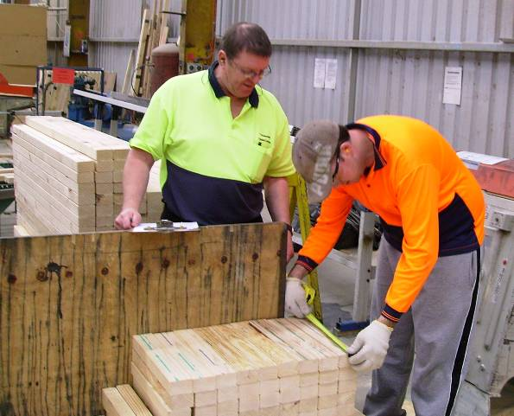There are many things you can do to help the company use resources more efficiently. In this section, we’ll look at some simple measures that can be carried out in the workplace at any time.

You’ll probably agree that all of these actions are commonsense, and you may already be doing some of them. But it helps to remember that each positive action makes its own contribution to a more environmentally sustainable workplace, and in the end, a healthier natural world.

At an economic level, most of these ideas will also save your company money. You’ll be using less materials, consuming less power and disposing of less waste. So you can be pretty confident that if you’re not already making use of these ideas, your boss will support any new measures that have the effect of improving the company’s efficiency and profitability.

### Completing this section

The assignment for this section asks you to think about the sustainability measures in place at your own your own worksite. Are they effective? Can any of them be improved? How would you go about implementing improvements? Have a look at *Assignment 3* on page 34 to see what you’ll need to do to complete it.

There are three lessons for this section:

* *Using less power*
* *Using less water*
* *Managing waste*

These lessons will provide you with background information relevant to the assignment.

|  |
| --- |
| Using less power |

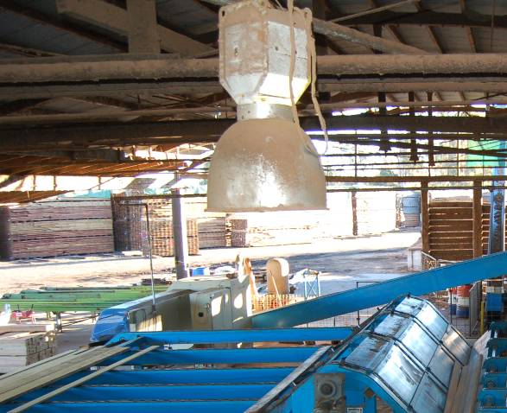Reducing the amount of electricity you use at work will not only save your company money, it will also make a difference to the greenhouse gas emissions produced by power generators.

#### Lighting

The simplest ways to reduce artificial lighting costs are to:

* use natural light as much as possible
* turn off the lights that aren’t needed.

#### Equipment

With equipment, you’ll save power by:

* turning off the machine when you’re not using it
* cleaning and maintaining equipment regularly
* replacing inefficient parts or machines
* checking air hoses and compressors for leaks.

|  |
| --- |
| Using less water |

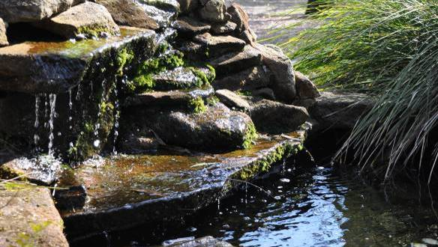There was a time when people didn’t give much thought to how much water they used at home and work, because it seemed that the supply was endless and it cost almost nothing. But those days have gone. Long term changes in the weather patterns, combined with a series of devastating droughts in various parts of Australia, have meant that water restrictions have become a fact of life for most people.

Many manufacturing businesses now use rain water, bore water or recycled water to supplement their supply. They have also installed more efficient appliances and equipment where possible. However, there are various things that anyone can do on a day-to-day basis to reduce their consumption of this scarce natural resource.

Firstly, of course, you need to comply with any local government water restrictions. This may include not hosing hard surfaces, and not using sprinklers. Secondly, use mulch on garden areas, to reduce the amount of outdoor watering you need to do. And thirdly, fix leaking taps or fittings, so you don’t lose any water unnecessarily.

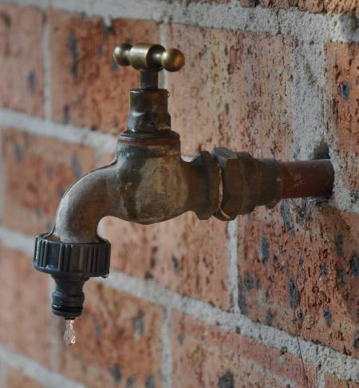Just to give you an idea of the savings these simple measures can make, here are some facts and figures on common water usages and wastages.

* A dripping tap loses between 30 and 200 litres a day.
* A leaking fitting, or a pipe with a 1.5 mm hole in it can lose 100 litres of water a day.
* A leaking toilet cistern can lose from 35 litres a day, for water that is just visible in the pan, up to 260 litres, for water that makes a   
   constant hissing sound.

|  |
| --- |
| Managing waste |

It goes without saying that the easiest way to deal with the problem of waste is not to create it in the first place. But that’s not always possible, of course, so the next best way to minimise waste is to try to re-use the materials wherever you can.

If you can’t do that, you then have to consider whether the discarded items could be broken down to their raw materials again and made into new products.

This hierarchy of options is referred to the 3 Rs – **Reduce, Reuse, Recycle**. Notice that **disposal** doesn’t even rate a mention in the 3 Rs, because it is the last resort, and should only be used if you’ve already exhausted the other possibilities.

Here are some practical examples.

### Reduce

Try to use materials as efficiently as you can, and minimise the amount of reject stock you produce. If you need to cut certain materials to specific sizes, work out which stock sizes will give you the best recovery, and therefore the least amount of off-cuts.

### Reuse

See if your suppliers can deliver their products in returnable packaging, such as pallets and drums. Then they can pick them up when they drop off your next order. The same thing applies to plastic containers.

### Recycle

Many products are now recyclable, and some companies offer to pick them up for free, or even pay you by the tonne when they collect them. Recyclable materials include glass, aluminium, steel, plastic, paper and cardboard, and toner cartridges.

### Disposal

If you need to store waste while it’s waiting to be picked up and disposed of, make sure it is kept secure so that it doesn’t blow away or escape into the storm water system. Remember, too, that you mustn’t bury waste on-site – this constitutes a landfill activity and is illegal unless your company has an EPA waste licence.

Never put liquid waste into the waste bin. Materials in the waste bin generally go to landfill, so it should only ever be used for dry, solid waste. Always drain and clean anything containing leftover fluid before you put it in the bin. Depending on the type of liquid it is, you can then either recycle or treat it, or put it aside for removal by a waste disposal contractor.

|  |
| --- |
| Assignment 3 |

**Question 1: Using less water**

Take a walk around your worksite and look for any areas where water is leaking or being used unnecessarily. The issues you find could include dripping taps, leaking connections, inefficient sprinkler systems, or even work practices that use excessive water. Describe the problem and the best way to fix it. Who would you report this problem to?

**Question 2: Using less power**

Think about the ‘non-process’ power usage in your workplace – that is, the electricity used in activities not directly related to production. Areas could include amenities buildings, lunchrooms, kitchens, store rooms, and so on. Are there any actions that could be taken to conserve power usage? Describe what they are and who would be involved.

**Question 3: Managing waste**

1. What are the ‘3 Rs’ of waste management?
2. Name an item or material that you apply this principle to at work, and describe what you do with it. If you don’t already apply this practice, describe what you could do in the future

**Question 4: Suggesting improvements**

Who is responsible for environmental care in your workplace? If you came up with a new idea that made a work activity more environmentally friendly, how would you go about putting it to the company?

**Completing this assignment**

You will find a hard-copy template for this assignment in your Workbook. There is also an electronic version of the template on the website. See the *Introduction* (page 1) for more details on how to access this file.