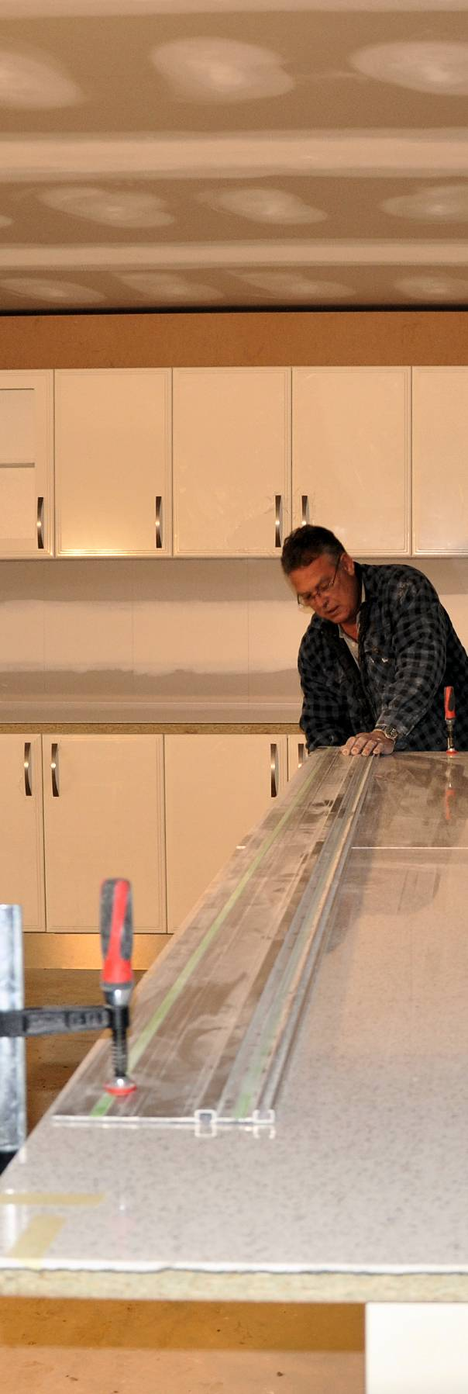

**Learner guide**

**Developed in 2011-2012 for the WELL Program**

Processes in kitchen   
and bathroom projects

DRAFT VERSION

October 11



**Supporting:**

***LMFKB3001A  
Identify processes in kitchen and bathroom projects***

Processes in kitchen and bathroom projects

Learner Guide

This unit is also available in an e-learning format, which contains additional photos, interactive exercises and a voice-over narration of the text. It can be viewed on CD-ROM, or live on the web at:

<http://www.kbcabinetmaking.com.au/>



Developed by Workspace Training for the 2011-2012

Workplace English Language and Literacy (WELL) Program

Kitchen and Bathroom Cabinetmaking resource development project



[www.workspacetraining.com.au](http://www.workspacetraining.com.au)

ISBN: 978-0-9873328-5-1

Funded under the Workplace English Language and Literacy Program by the Australian Government through the Department of Education, Employment and Workplace Relations.

COPYRIGHT

© Commonwealth of Australia. 2012



***CC BY-NC-SA***

This work is copyright. Except where otherwise indicated, and save for the Commonwealth Coat of Arms, the Department has applied the Creative Commons Attribution-Noncommercial-Share Alike 3.0 Australia Licence to this work.

The Department of Education, Employment and Workplace Relations must be attributed as the author of the Department’s copyright material.

As far as practicable, material for which the copyright is owned by a third party has been clearly labelled. The Department has made all reasonable efforts to ensure that this material has been reproduced in this print-based resource and the accompanying website with the full consent of the copyright owners.

Requests and enquiries concerning the Department’s copyright material should be addressed to:

The Copyright Officer

Department of Education, Employment and Workplace Relations

Location code C148CW2

GPO Box 9880 Canberra ACT 2601

Email: [copyright@deewr.gov.au](mailto:copyright@deewr.gov.au)

Questions about the design and content of the resource itself should be addressed to the project manager:

David McElvenny

Workspace Training

PO Box 1954 Strawberry Hills, NSW, 2012

Email: [david@workspacetraining.com.au](mailto:david@workspacetraining.com.au)

## About this resource

This learner guide is one of 11 learner guides developed for the *Kitchen and Bathroom Cabinetmaking* project, funded by the WELL Program in 2011-2012. The guides are aligned to the following core and elective competencies from the *Certificate III in Cabinetmaking (Kitchens and Bathrooms) LMF32109*:

*LMFKB2001A Prepare for cabinet installation*

*LMFKB3001A Identify processes in kitchen and bathroom*

*LMFKB3002A Determine requirements for installation*

*LMFKB3003A Check and measure fit of cabinets*

*LMFKB3004A Conduct on-site adjustments to cabinets*

*LMFKB3005A Fabricate cabinets for the built-in environment*

*LMFKB3006A Install fitted cabinets and components*

*LMFFM3006B Install furnishing products*

*MSAENV272B Participate in environmentally sustainable work practices*

*MSAPMOHS200A Work safely*

*MSAPMOPS101A Make measurements*

The purpose of the guides is to help apprentice cabinetmakers acquire the background knowledge needed to satisfy the theoretical components of these units. However, they are not designed to replace the practical training necessary to develop the hands-on skills required. Learners will still need to receive extensive on-the-job training and supervision before they will be ready to be formally assessed in these units.

### E-learning version

All of these units are also available in an e-learning format, which contains additional photos, interactive exercises and a voice-over narration of the text. The   
e-learning version can be viewed live on the web at:

<http://www.kbcabinetmaking.com.au/>

The web version can also be purchased on a CD at a cost-recovery price from the project developer:

David McElvenny (project manager)

Workspace Training

PO Box 1954 Strawberry Hills, NSW, 2012

Email: [david@workspacetraining.com.au](mailto:david@workspacetraining.com.au)

## Acknowledgements and disclaimer

### Project team

Project manager: David McElvenny

Instructional design: Kath Ware

Technical developer (website): Jim Vaughan

Assistant technical developer (and voice-over artist): Alex Vaughan

Quality assurance consultant: Giselle Mawer

Industry coordinator: Gary Dunshea (MSA Industry Skills Council)

Lead advisor: Rob Cole (Furnishing Industry Association of Australia)

### Technical Advisory Group

**New South Wales**

Brad Holmes – Hunter TAFE

Grant Cohen – Hunter TAFE

Dean Brakell – Furnishing Industry Association of Australia

Warren Peters – South West Sydney Institute of TAFE

Sean Greening – South West Sydney Institute of TAFE

**ACT**

Martin Jud – Canberra Institute of Technology

**Victoria**

Bryon Stanley – Furnishing Teacher's Advisory Group (VIC, SA, TAS)

Richard Brooks – Cabinet Makers Association

Simon Hampton – Wodonga TAFE

John Simpson – Holmesglen TAFE

**Tasmania**

Stephen Kirkman – Skills Institute Tasmania

**Queensland**

Rob McAdam – Skills TECH Australia

Brad Buhse – Skills TECH Australia

Roberto Viola – Gold Coast Institute of TAFE

**South Australia**

John Holst – Marleston TAFE

Dean Hart – Mt Gambier TAFE

Martin Videon – Furnishing Industry Association of Australia

**Northern Territory**

Hermann Oltrop – Charles Darwin University

**Western Australia**

Garry Michels – Polytechnic West

Keith Campbell – Polytechnic West

Adrian Boyling – Polytechnic West

David Boaden – Polytechnic West

Lorenzo Procopio – South West Institute of Technology

**National**

Laurie Kruize – Housing Industry Association

### Photographs and graphics

All photos were taken by David McElvenny. All graphics were drawn by Kath Ware. We would like to thank the following companies for allowing us to take photos of their installers and workshop employees and generously providing technical advice:

Canobolas Kitchen Designs Flair Kitchens

Danson’s Kitchens and Joinery Lamtex Innovative Furniture

Fewings Joinery Stateline Cabinets

B&B Joinery Ian McConnell Constructions

Krauss Kitchens

### Financial contributions

This resource was largely funded by the Workplace English Language and Literacy Program, through the Department of Education, Employment and Workplace Relations. However, due to the scale of the project and the provision of print-based and website resources, additional financial assistance was provided by the following organisations:

Manufacturing Skills Australia (Industry Skills Council)

Furnishing Industry Association of Australia

### Disclaimer

The content of this learner guide is provided for educational purposes only. No claim is made as to the accuracy or authenticity of the content. The views expressed in this publication do not necessarily represent the view of the Minister for Education or the Australian Government. The Australian Government does not give any warranty nor accept any liability in relation to the contents of this work.

**Table of contents**

[**Introduction 1**](#_Toc306343987)

[Section 1](#_Toc306343988) [Trades and services 3](#_Toc306343989)

[Overview 5](#_Toc306343990)

[Main trades 6](#_Toc306343991)

[Other trades and services 9](#_Toc306343992)

[Assignment 1 12](#_Toc306343993)

[Section 2](#_Toc306343994) [Key stages 13](#_Toc306343995)

[Overview 15](#_Toc306343996)

[Site assessment 16](#_Toc306343997)

[Developing the design brief 18](#_Toc306343998)

[Developing the project plans 21](#_Toc306343999)

[Contracts and legislation 24](#_Toc306344000)

[Final preparations 26](#_Toc306344001)

[The building phase 28](#_Toc306344002)

[Assignment 2 30](#_Toc306344003)

[Section 3](#_Toc306344004) [Manufacturing processes 33](#_Toc306344005)

[Overview 35](#_Toc306344006)

[Changing designs 37](#_Toc306344007)

[Cabinet construction 39](#_Toc306344008)

[Materials and processes 41](#_Toc306344009)

[Assignment 3 44](#_Toc306344010)

[Section 4](#_Toc306344011) [Quality elements 45](#_Toc306344012)

[Overview 47](#_Toc306344013)

[Finding information 48](#_Toc306344014)

[Supply sources 50](#_Toc306344015)

[Standards 52](#_Toc306344016)

[Quality inspection 55](#_Toc306344017)

[Assignment 4 57](#_Toc306344018)

|  |
| --- |
| Introduction |

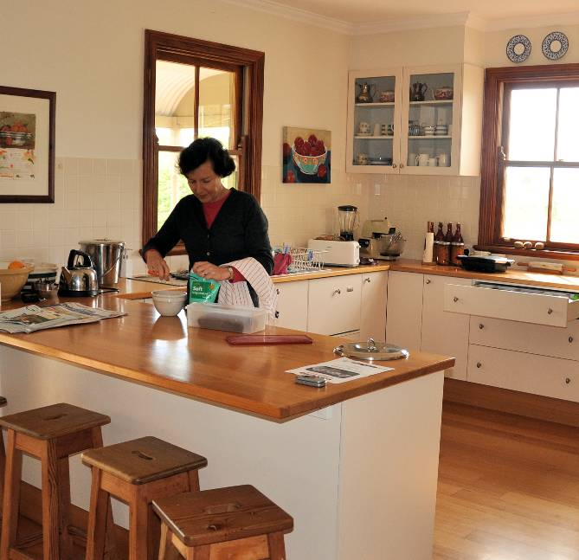A kitchen is often the busiest room in the house. It’s also the most complex room to build, with a wide range of built-in features and appliances, together with services such as electricity, water and gas. Bathrooms are also specialised rooms, with many built-in features customised to the needs of the occupants.

The purpose of this unit is to provide an overview of the processes involved in installing a kitchen or bathroom. We won’t go into the details of cabinet manufacture or installation, because these are covered in other units in the Kitchen and Bathroom Cabinetmaking qualification. But we will look at the sequence of stages, the people involved, construction methods, and the main factors that determine the quality of the finished project.

### Working through this unit

There are four sections in this unit:

1. Trades and services
2. Key stages
3. Manufacturing processes
4. Quality elements.

Each section contains an *Overview*, an *Assignment*, and several *Lessons* which cover the content material. Your trainer may ask you to submit the assignments as part of your assessment evidence for the unit. You will find hard-copy templates for these assignments in the separate workbook.

Electronic ‘Word’ versions of the assignment templates are available on the website for this resource, at: <http://www.kbcabinetmaking.com.au/>

The electronic versions can be completed on-screen and sent to the trainer either as:

* a printed hard copy, mailed through the post
* an electronic file, emailed as an attachment.

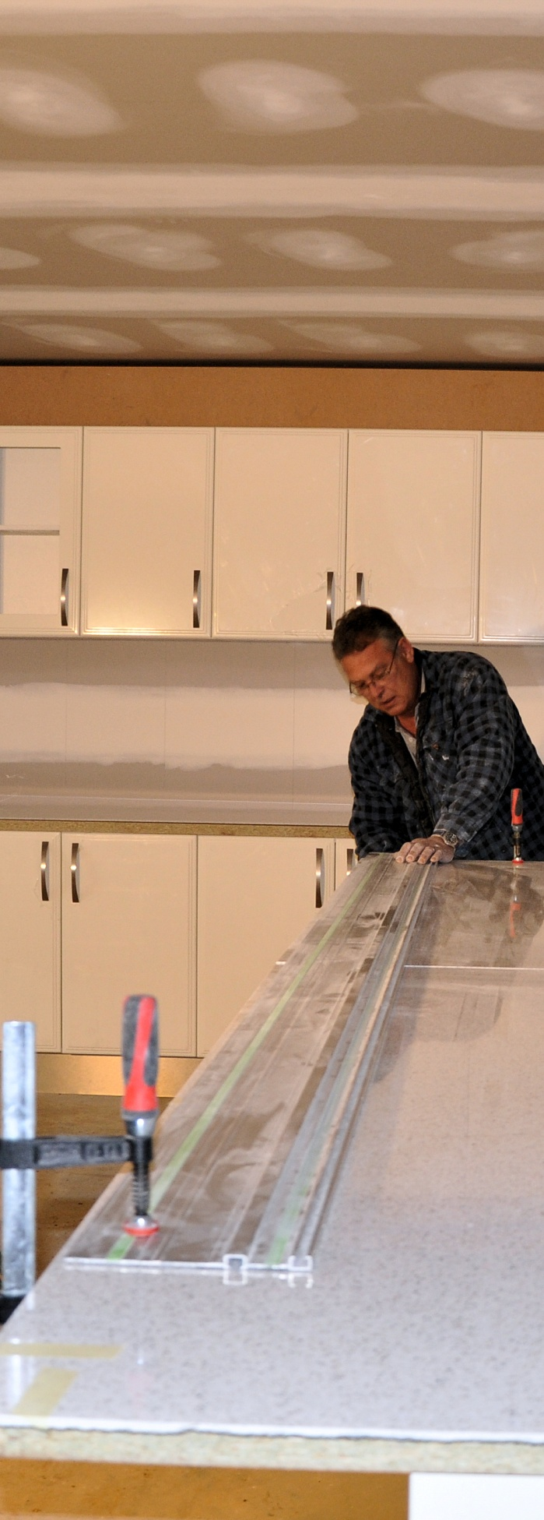

# Section 1

# Trades and services

|  |
| --- |
| Overview |

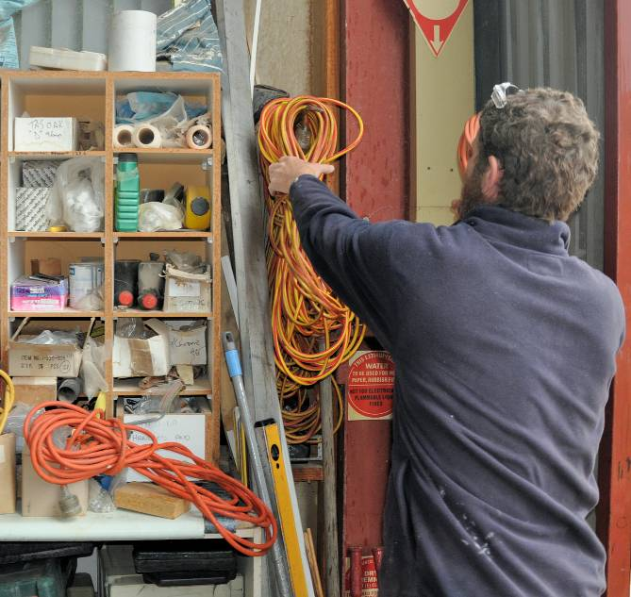Various trades are needed to carry out the specialised work involved in building or renovating a kitchen or bathroom. Although there are some obvious differences between kitchens and bathrooms in the nature of the work to be done, the tradespeople are generally the same.

In this section, we’ll discuss these trades. We’ll also look at the support services often provided by other professions and trades.

### Completing this section

The assignment for this section is designed to help you learn what each of the main trades do and the sequence they work in. It will also give you practice in developing a simple project schedule for a renovation job. Have a look at *Assignment 1* on page 12 to see what you’ll need to do to complete it.

There are two lessons for this section:

* *Main trades*
* *Other trades and services*

These lessons will provide you with background information relevant to the assignment.

|  |
| --- |
| Main trades |

Apart from cabinetmaking, the main trades involved in a typical kitchen or bathroom project are actually part of the ‘building’ industry. Cabinetmaking stands out because it is considered part of the ‘furnishing’ industry, given the fact that it comes from the tradition of making free standing furniture.

For the purposes of the summaries shown below, we have kept the descriptions of the building industry tradespeople to their roles in kitchen and bathroom installations. However, in practice their skills would extend to many other aspects of building and construction.

### Cabinetmaker

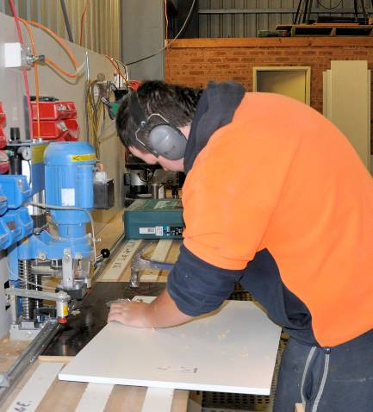Kitchen and bathroom cabinetmakers build modular units and customised cabinets. Some cabinetmakers spend all of their time in the workshop, prefabricating the cabinets, bench tops and other components that will go into the project.

Others specialise in on-site measure-ups and installations. In small businesses, the whole process may be carried out by the same person or team, from the measure-up, to the manufacture of the units, right through to the final installation.

### Carpenter

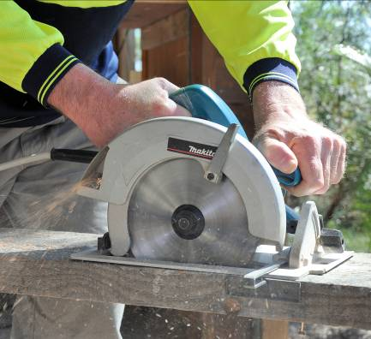Carpenters have a lot in common with cabinetmakers, and use many of the same tools. However, they are more involved in the structural aspects of the project, particularly when the building framework is made of timber or steel.

Their job is to carry out the modifications or new work on the floor, walls and roof, which may also include installing windows, hanging doors, and fixing skirtings and architraves.

### Plumber

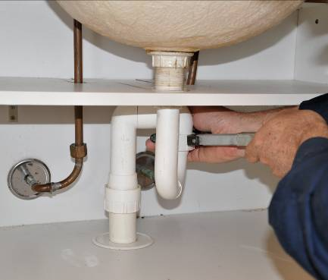Plumbers look after all work involving water, gas, sewerage and wastewater. They need to work on the job before and after the cabinets are installed and tiling is done. Their first visit will be to run the pipes through the wall frames or floor, ready for the internal fit-out. Once the cabinets have been installed and tiling or other wall linings completed, they will come back to connect up the taps, sinks and other plumbing fixtures.

### Electrician

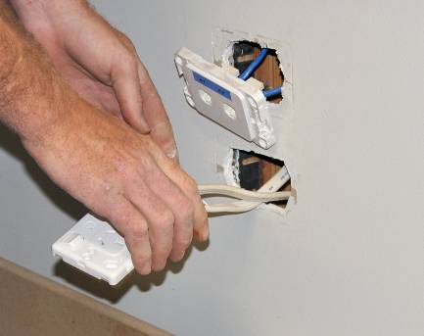Electricians work with ‘mains’ electricity, often referred to as ‘240 volt power’. In some cases they also work with ‘three phase’ electricity, particularly in industrial buildings. Like the plumber, they need to come on-site before and after the cabinetry installation, firstly to run the wiring that will be needed and, when they return, to connect the appliances, power points and other electrical fixtures.

### Tiler

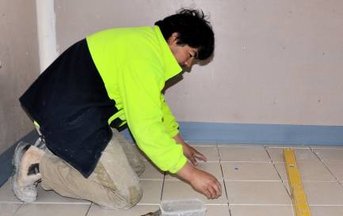Not all kitchen projects use tiles, but just about every bathroom job does. This is because tiles are an excellent way of producing durable, waterproof and easy-to-clean walls and floors. Tilers generally work with ceramic or slate tiles, which are either glued in position or bedded in with cement-based mortar.

##### Learning activity

Anyone who works as a contractor in the above trades needs to be licensed by the state or territory authority that controls business activities. In some states the requirement applies to all construction jobs over a certain value, such as $1000.

However, two of these trades require special licences, and only people who hold these specialist trade licences are permitted to do any work in these fields, regardless of the cost.

Do you know which trades they are? Why do you think there are laws restricting this sort of work to special licence holders?

Share your answers with your trainer and other learners in the group.

|  |
| --- |
| Other trades and services |

So far we’ve looked at the immediate trades involved in a typical kitchen or bathroom project, in particular those that work in closely with the cabinet and bench top installers. But there may be other specialists needed for particular parts of the job, depending on the complexity of the project and the client’s requirements.

Set out below are some of the other trades and professional consultants who might be involved in the project.

### Architect

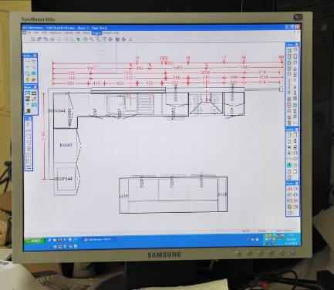Architects are professional designers with a sound knowledge of building materials and construction techniques. In a kitchen or bathroom project, they may become involved if the client wants to create a one-off design on a new project, or remodel the room in an existing building. The architect works closely with the client to produce the ‘look and feel’ they are striving for, and draws up the plans and building specifications for the tradespeople to follow.

### Demolisher

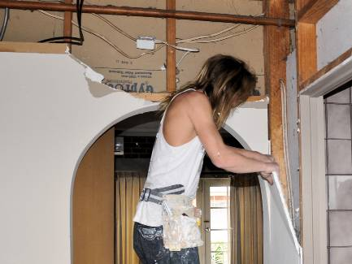Demolition workers are most likely to be called in when parts of an existing building need to be removed that contain asbestos fibro sheeting, masonry walls, concrete, or other materials that are difficult to demolish. They’re not tradespeople as such, but they are required to be licensed when they remove and dispose of hazardous materials such as lead and asbestos.

### Glazier

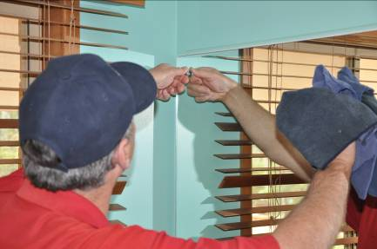Glaziers handle glass and mirrors. In the workshop they cut glass to size and install it into windows and other prefabricated components. They also put decorative edges, such as bevelled edges, onto mirrors. Where the project requires sheets of glass or mirrors installed directly in position, they bring the pre-cut pieces to the site and install them ‘in-situ’.

### Plasterer

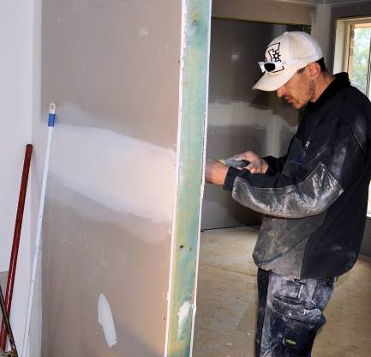Traditionally, plasterers worked with wet plaster or cement-based mortar to produce a smooth surface on walls and ceilings. This process, called ‘solid’ plastering, is still used when the internal walls are made of brick or other masonry.

But in timber or steel framed buildings, plasterers now use dry plasterboard (such as Gyprock) sheets made of gypsum faced with cardboard. However, they still fill the joints and nail indentations with a plaster-like compound.

### Stonemason

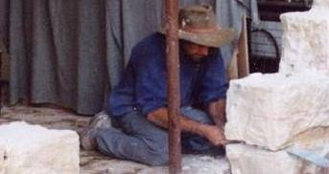If the client has specified a customised stone bench top, a stonemason will be needed to cut the natural or artificial stone to size and shape and then polish and finish it. They may also be involved in structural work if the building has stone walls.

### Painter

The painter is one of the last people on the job, because their task is to fill any blemishes in the walls and ceilings, and paint the surfaces in the colours requested by the client. If the project includes natural timber cabinets or doors, they may also apply the stains or clear finishes to the timberwork.

### Flooring specialist

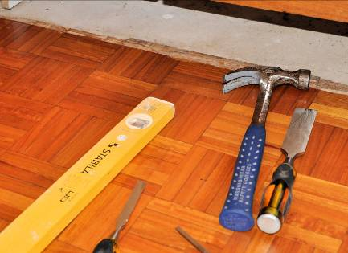The choice of flooring specialist will depend on the type of work to be done and the structure of the subfloor. In a bathroom, the flooring is likely to be installed by the tiler. However, in a kitchen there are various other choices available, including solid timber ‘strip’ flooring, timber parquetry, cork, vinyl, and veneered boards.

##### Learning activity

We’ve mentioned above that demolition workers are sometimes called on to remove hazardous materials from the jobsite, such as lead and asbestos. But on smaller projects, it’s quite possible that you’ll come into contact with these materials yourself, particularly if you’re installing cabinets in a building built before the 1970s.

What types of building materials are you likely to be working around that might contain asbestos? Where will these products be in the building structure? What should you do if you need to disturb these products?

Where are you likely to find lead or lead-based products in an old home? What should you do if you think that a product contains lead and you need to remove or disturb it?

Share your answers with your trainer and other learners in your group.

|  |
| --- |
| Assignment 1 |

The following pieces of equipment are commonly used in kitchen and bathroom installations. For each one, name the item, describe its main purpose, and identify the trade (or trades) that are most likely to use it.

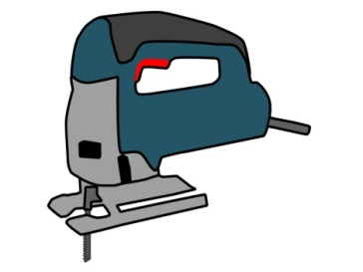

**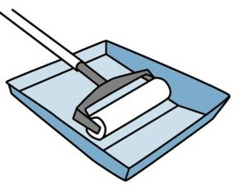**

**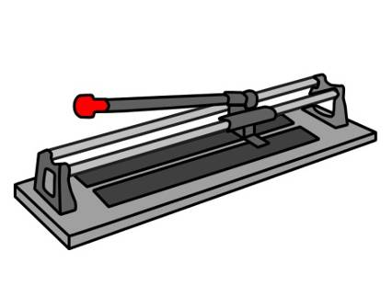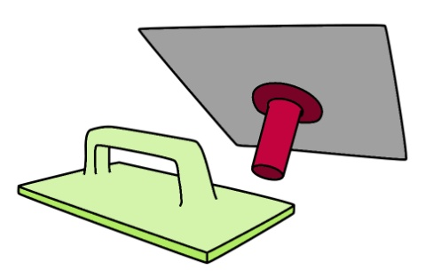**

**** 

### Completing this assignment

You will find a hard-copy template for this assignment in your Workbook. There is also an electronic version of the template on the website. See the *Introduction* (page 1) for more details on how to access this file.



# Section 2

# Key stages

|  |
| --- |
| Overview |

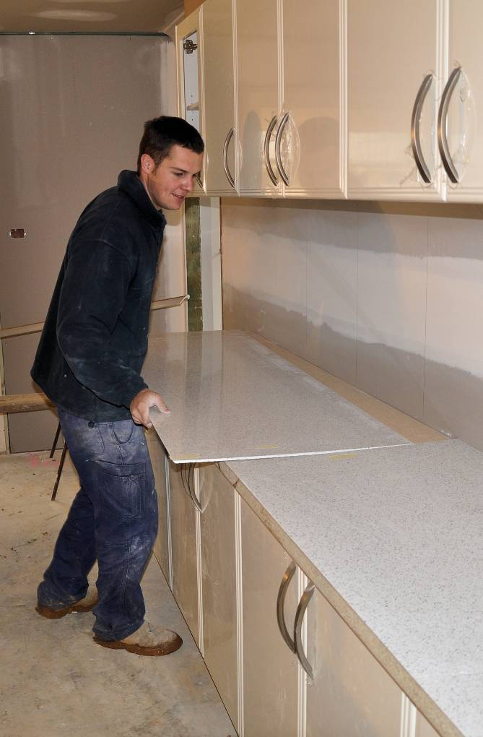There are various stages involved in kitchen and bathroom projects. Whether it’s a renovation or new installation, the stages will be much the same. The only difference in a renovation project is that the old fixtures will have to come out, and doorways or windows may need to be moved.

In general, there are two phases in a kitchen or bathroom project: the design phase and the building phase.

We’ll cover the design phase in the following lessons in this section:

* *Site assessment*
* *Design brief*
* *Project plans*
* *Contracts and legislation*
* *Final preparations.*

In the remaining lesson we’ll introduce the activities that make up the construction stage of the project. It’s called:

* *The building phase*.

### Completing this section

The assignment for this section is designed to give you practise in developing a simple project schedule for a renovation job. Have a look at *Assignment 2* on page 30 to see what you'll need to do to complete it.

Then work through the lessons and learning activities in this section. These will provide you with background information relevant to the assignment.

|  |
| --- |
| Site assessment |

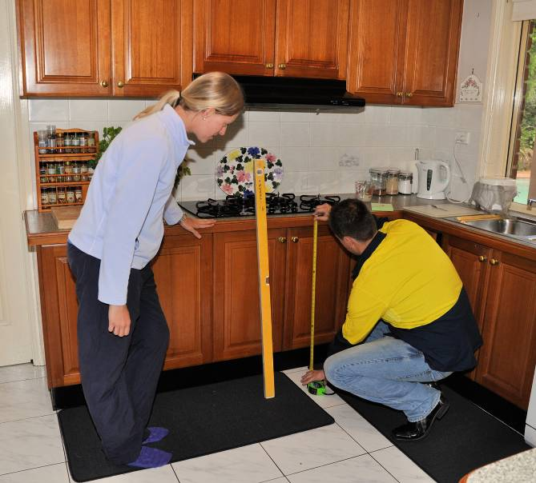Before you prepare a quotation for a kitchen or bathroom project, you need to talk to the client about the details of the job. It’s important to meet with the client at least once on-site. This allows you to talk about the design while you’re standing there, and compare the plans and other working drawings with the actual building.

If the job is a renovation project, you’ll also talk to the client about any remodelling that needs to be done to the existing structure, such as moving walls, doors or windows.

The process of checking the details of the job on-site and confirming measurements is called the **site assessment**. Set out below are the sorts of things you might need to check during this process. Naturally, there will be some differences between a site assessment for a new project and one for a renovation. However, the general approach will be much the same.

### Building structure and materials used

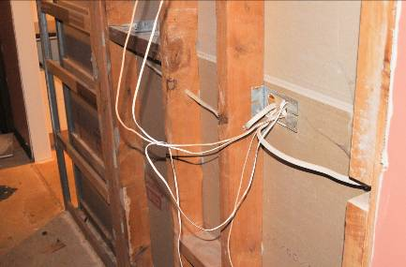The construction of the floor, walls and ceiling will have a bearing on your installation methods. As well as looking at the structure and materials used in the floor and walls, you should also check the levels in the floor and squareness of the walls. If you are renovating an older building, remember to look out for hazardous materials, such as asbestos fibro sheeting.

### Room design

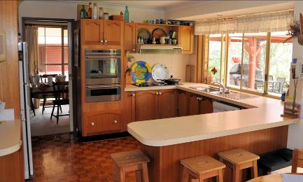This includes the shape of the room, positioning of windows, and any architectural features. These factors will influence the design and appearance of the cabinets and other aspects of the project. Your client may want advice on practical ways to create the ‘look and feel’ that they’re trying to achieve.

### Access to the work area

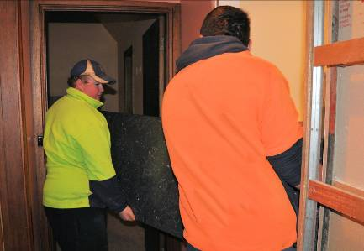If the rooms you’re working in are above the ground floor, you may need to manoeuvre cupboards and materials through stairwells or lifts. General site access could also be limited due to trucks in the way or parking restrictions on the street. It’s best to take these potential problems into account before you agree on a final price with the client.

### Positioning of services

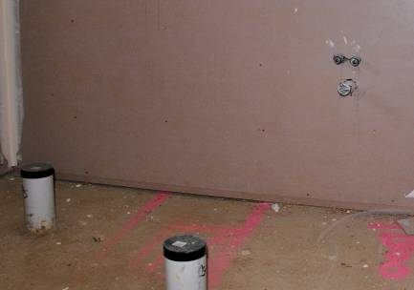Outlets for water, sewer, gas, electrical points and air conditioning should be carefully noted. You need to make sure that the cut-out positions in the cabinets are correct so that the pipes and cables will run through easily. You also need to anticipate any problems in advance for the tradespeople who will connect up these services.

##### Learning activity

Have a think about the sorts of things you should take with you when you go out to the site to do an initial assessment. For example, one item that would be very useful is a digital camera, because you could photograph various aspects of the job to refer to back at your own workshop.

What other tools, items or pieces of equipment should you take with you?

Write up a list, naming each item and describing what its purpose is. Share your answers with your trainer and other learners in the group.

|  |
| --- |
| Developing the design brief |

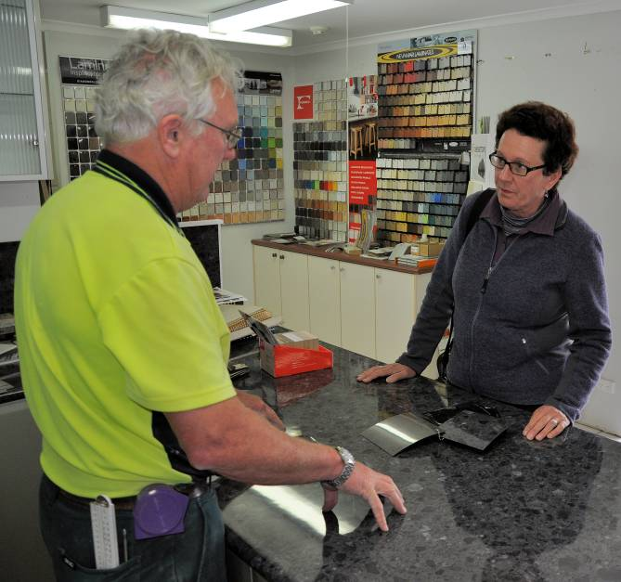Most clients will come to you with a general idea of the design they’re looking for in a new bathroom or kitchen. But they’re likely to be rather vague on the details.

This is generally because they don’t have the technical understanding required to simply hand you a set of specifications for the project. They may also not be aware of the full range of possibilities available until you present the various options to them.

The best place to carry out a design presentation is at the showroom. This could either be at your own workplace or at a building advisory centre or manufacturer’s showroom.

Depending on the size of the project, you may need more than one meeting to fine tune the details required to draw up the document called the **design brief**. The design brief is the document that describes the client’s objectives and sets out the requirements and final design.

There are three basic stages in preparing the brief, as shown below.

### 1. Develop a preliminary design

Below are the typical steps involved in your first meeting with the client to establish a suitable design and the scope of the project.

1. Show the client computer generated 3-D drawings of the different designs available.
2. Identify the product options for the various components of the project.
3. Discuss the budget and tailor the design accordingly.
4. Agree on the preliminary design, project scope and budget.

### 2. Develop a final design

The final design stage is where you collect all the detailed information you’ll need to prepare the design brief. The steps involved are as follows:

1. Finalise the product selection on the items to be included, such as:

* cabinets, bench tops and appliances
* windows, doors and hardware
* plumbing fixtures, taps and accessories
* electrical fittings and lighting
* wall and ceiling finishes
* flooring (which may include tiles, timber, laminates, vinyl or carpet).

1. Review the final design plans and incorporate any changes.
2. Review the project specifications.
3. Review the budget based on final design and selections.
4. Organise temporary services, such as a portable bathroom or temporary kitchen.

### 3. Prepare the design brief

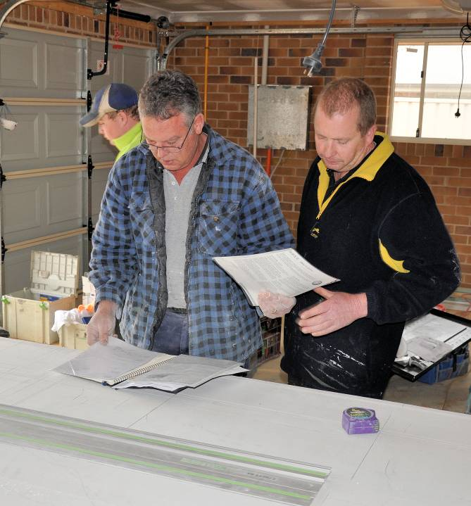A well prepared design brief can be used as a reference document throughout the course of the project to make sure the work being done is in keeping with everyone’s expectations. It should also form a central part of the contract between the client and the contractor.

The design brief is likely to contain the following elements:

* client’s needs and objectives
* requirements and design features
* timeline for the project, showing milestones for particular stages
* budget
* standards that apply, including criteria that will be used to evaluate the finished project
* consultation arrangements.

##### k&b_la_drawingLearning activity

Your own workplace will use some form of design brief, even if it goes by a different name. Ask your boss or supervisor if you can have a look at the design brief for a job you’ve done recently, or one you’re currently working on.

What elements does it include? Write down the main headings and briefly describe what each one covers.

Share your answers with your trainer and other learners in the group.

|  |
| --- |
| Developing the project plans |

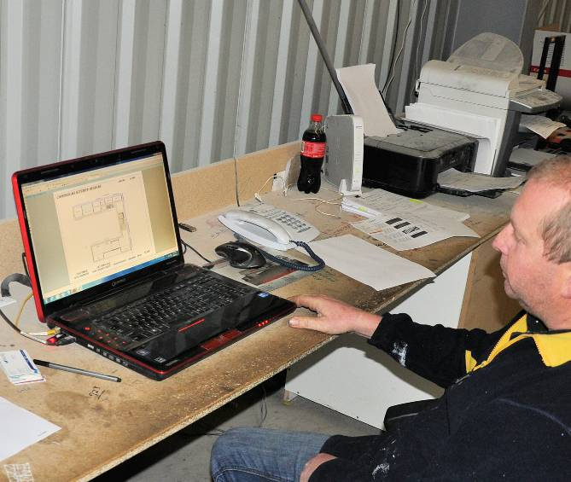It’s often tempting to hop straight into a new project as soon as you get the go-ahead for it. But as every experienced contractor knows, there is no substitute for careful planning.

A sound project plan can save you a lot of grief further down the track, and help you complete the project on time and on budget. Forward planning lets you predict problems that might occur and take steps to avoid them before they happen.

It also enables you to coordinate the different aspects of the job, especially the separate trades and the various stages that need to be completed in a particular sequence.

Set out below are the main steps involved in developing a project plan.

### 1. Define the objectives

Obviously, the overall objective of the project will be to satisfy the client’s needs. But exactly what are those needs, and are they in keeping with the budget allowed, the timeline proposed, the workers on hand and the materials available?

These objectives will become the **deliverables** for the project – in other words, the things that you must ‘deliver’ to meet the client’s requirements.

### 2. Develop a project schedule

The project schedule lists all of the tasks that need to be carried out to achieve the deliverables. It should include the people involved, the number of hours (or days) required for each section of the job, and the sequence that the tasks need to be done in.

There are various software packages available for developing project schedules. They contain electronic templates with different fields for entering tasks, durations and resources. Once you have entered the data you can generate a timeline and then modify the time allocations to get the most efficient schedule.

If it turns out that your deliverables can’t be achieved under the existing arrangements, you may have to renegotiate the details with your client. The main aspects you might need to vary are:

* the deadline for final completion
* the total cost of the project
* the scope of the project.

### 3. Develop supporting plans

Depending on the size and scale of the project, you may need to develop various supporting plans to control particular parts of the job. These would include:

**Human resources plan**, listing the details of the tradespeople and other workers involved, and describing their roles, responsibilities, contractual arrangements, and so on.

**Communication plan,** showing who needs to be kept informed, and the process workers must follow to report on their progress and any delays that have occurred.

**Risk management plan,** identifying things that could go wrong and ways of reducing the risks.

##### Learning activity

We’ve said that a *Risk management plan* may need to be developed as one of your supporting plans, particularly if the project is a large one. But even on small jobs where you don’t need a formal risk management document, you should still think about the potential risks while you’re planning. This will help you to look ahead and nip problems in the bud before they cause too much damage.

Think of a typical project that you’re likely to be involved in, or maybe even one that you’re working on at the moment. What are some of the main things that could go wrong? How would you stop them from happening – that is, what control measures could you put in place?

Here’s some suggestions on possible risks in a project:

* cost blow-outs
* time delays
* poor workmanship or mistakes
* misunderstandings with the client.

Write down your answers and share them with your trainer and other learners in the group.

|  |
| --- |
| Contracts and legislation |

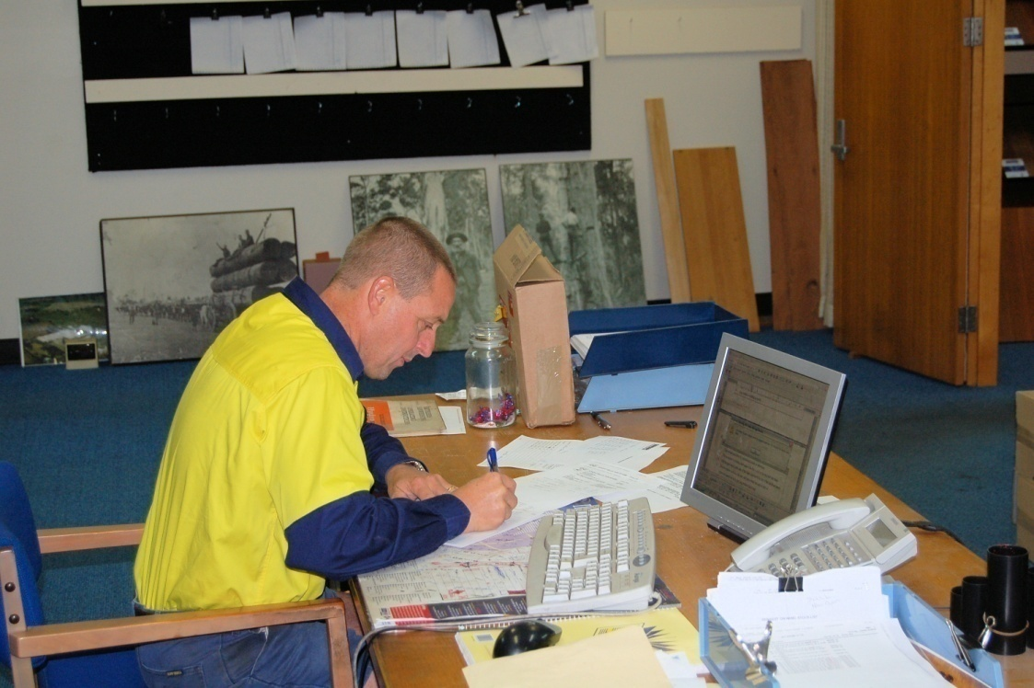The language of the law is often hard to understand. But that doesn’t mean that you can simply ignore it. As the old saying goes: ‘Ignorance of the law is no defence’.

Fortunately, there are various industry associations and government bodies that provide ‘plain English’ explanations of your legal responsibilities in building activities, and some also offer template contracts for you to use with your clients.

Set out below are the main legal issues you need to be aware of when you’re tendering for a project.

### Contracts

The states and territories vary on whether or not a written contract is needed to carry out particular types of building work. However, for your own peace of mind, you should always enter into a written contract before you start any kitchen or bathroom project.

This will spell out clearly what your obligations are to the client, and what their obligations are to you. If you ever did end up with a dispute on your hands, the contract will protect your rights and give you a legal basis for resolving the issue fairly.

The types of issues that a contract covers include:

* full description of the scope of work to be undertaken
* progress payments and stages of work to be completed
* processes for varying the terms of the contract, such as deadlines or costings
* what to do if a defect is found in any of the products or workmanship
* the use of licensed tradespeople where required
* protection of your copyright in the designs or plans
* processes to follow if there is a breach of contract.

### Construction certificates

Again, the laws and council requirements vary depending on the state or territory you’re working in. However, in general, you will always need to obtain a **construction certificate** before any work can begin on a new project.

Construction certificates are issued by the local council, or alternatively a ‘private certifier’ authorised by the council. They verify that the project complies with the following legally binding documents:

* Development consent from the local council
* Building Code of Australia requirements
* Australian Standards that relate to the work to be performed.

##### Learning activity

What are the requirements in your state or territory regarding contracts for building work? Ask your supervisor or manager what the local regulations are.

You might also want to do your own research on this topic by going to your local council website or the government department that handles consumer protection. Note that each state and territory has its own name for this department, but it often contains the term ‘Fair Trading’ in it.

Write down your answers and share them with your trainer and other learners in the group.

|  |
| --- |
| Final preparations |

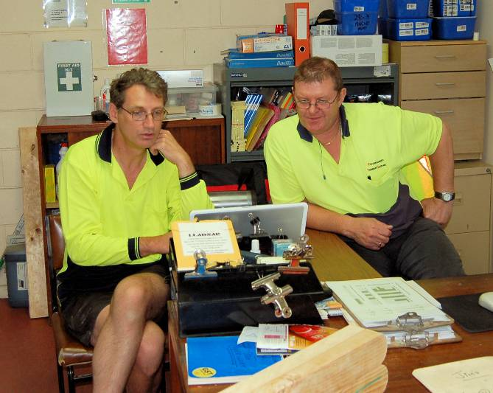Once the project plans are fully developed, it’s time to review everything. This will allow you to check that the details are correct and that arrangements will flow smoothly and efficiently. You’ll also need to meet with various people to confirm the final details and collect any remaining information.

Below are the main steps to follow in the final preparations.

### 1. Review the design brief and project plans

Questions you should ask yourself as you review these documents include:

* Has allowance been made for wet weather, public holidays, and delays in the supply of materials?
* Are the hardware items and appliances readily available from suppliers?
* Have all the tradespeople confirmed that they can start as per the schedule?
* Have all the necessary permits been approved?
* Is the client satisfied with the project schedule dates and details?

### 2. Meet with tradespeople and other workers

Unless you already know the tradespeople or other personnel, it’s best to meet with them in person so you can check their qualifications and talk to them about the job. You should give them a copy of the project schedule and discuss their timeline, so they understand where they fit into the overall plan.

Make sure that all documents are **version controlled** and that everyone has the latest version, so you can be sure that they’re all working with the same information.

### 3. Meet with the client

At this meeting you will go through the final arrangements and review all of the documents, including the design brief, construction plans project schedule and contract. The meeting will give you the opportunity to answer any questions the client may have and confirm that they understand the process that will be followed.

##### Learning activity

Under Step 1 above, one of the questions listed is: *Have all the necessary permits been approved?*

What sorts of permits do you or your client need to get for the projects you’re involved in? Name a particular type of project, list the permits required, and name the authorities responsible for granting approvals.

You might need to ask your supervisor or manager for help with this activity. Write down your answers and share them with your trainer and other learners in your group.

|  |
| --- |
| The building phase |

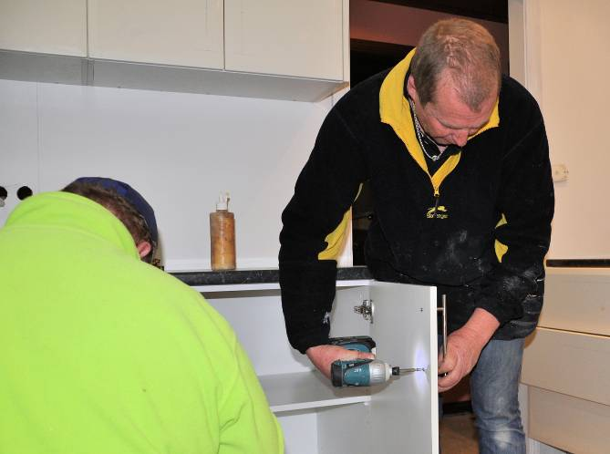Once the installation phase commences, the work will need to be carefully coordinated to make sure that the different stages are completed in the right sequence and within the set time frames. You need to monitor the tradespeople closely so that they don’t get in each others’ way, or have to wait for something else to be completed before they can finish their own work.

It’s likely that some parts of the project will be carried out in parallel, especially when the activities can be done at different locations. For example, you may have the cabinets being made at the workshop while the demolition work is underway on-site. See below for the sequence that normally applies to the on-site activities in a kitchen renovation.

### Sequence of work for a kitchen renovation

The usual sequence of on-site work for a kitchen renovation is as follows:

* disconnect all services, such as power, water and gas
* remove old cabinets, appliances and fittings
* relocate windows and walls, if necessary
* install basic plumbing and electrics
* install new flooring, if necessary
* install new cabinets, bench tops and tiling
* install appliances and lighting
* install plumbing fixtures
* seal and paint
* carry out a final inspection

### New projects

For new projects, the process will be much the same as above, except that no demolition or removal of old units will be required. This also means that the services don’t need to be disconnected, because they won’t yet have been installed.

##### Learning activity

Let’s say you’ve been asked to supervise the installation of a bathroom in a new project home. The subfloor is an on-ground concrete slab and the timber-framed walls have already been sheeted with Villaboard. What would your sequence of work be for the rest of the job?

List the activities and trades in their correct sequence. You can use the kitchen renovation sequence shown above as a guide.

Write down your answer and share it with your trainer and other learners in your group.

|  |
| --- |
| Assignment 2 |

Set out below are the various tasks required to renovate a kitchen. Your job is to write up a project schedule for this renovation.

Each trade is listed separately, with a breakdown of the number of hours needed to complete each stage of their work. Some of these stages – such as the plasterer’s sheeting, setting and sanding – can be done on consecutive days. But most of the stages done by the other trades will need to be re-ordered so that they work in with each other in the correct sequence.

Let’s say that the starting time for each day is 7 am, and that no work can be carried out after 5 pm. We’ll also say that no work is to be carried out on a Sunday. Note that some of the tradespeople will be able to work on the job at the same time, because they won’t be interfering in each others’ work. But in other cases – such as the plasterer and painter – you will only be able to have one trade working at a time.

How quickly can you get this project completed? Develop a project schedule, showing the starting and finishing times for each trade and day. Use the table in the template from your workbook to complete the schedule. Day 1 of Week 1 is done for you.

### Tasks required to renovate a kitchen

|  |  |  |
| --- | --- | --- |
| **Tradesperson** | **Task** | **Time (hrs)** |
| Carpenter | Prepare the work area, remove old kitchen cabinets and floor covering, remove wall and ceiling sheeting | 8 |
| Fit new door, skirtings and architraves | 6 |
| Electrician | Terminate power and look at scope of the job | 1.5 |
| Run new power cables for extra circuits | 4 |
| Connect stove, oven, exhaust fan and down lights | 4 |
| Plumber | Terminate water and look at scope of the job | 1.5 |
| Run new water and drainage pipes | 4 |
| Connect sink and dishwasher | 3 |
| Plasterer  (‘Gyprocker’) | Sheet the walls and ceiling, set the base coat (leave remainder of day) | 6 |
| Set the top coat (leave remainder of day) | 4 |
| Set the skim coat (leave remainder of day) | 4 |
| Sand the walls and ceiling | 2 |
| Tiler | Prepare the floor and lay tiles. (Note that there must be no traffic on the floor for one day after the tiles are laid) | 14 |
| Grout floor tiles | 4 |
| Tile walls (splashback) | 3 |
| Grout wall tiles | 2 |
| Polish tiles | 2 |
| Painter | Paint walls and ceiling | 8 |
| Cabinetmaker | Install kitchen cabinets and bench tops | 9 |

**Completing this assignment**

You will find a hard-copy template for this assignment in your Workbook. There is also an electronic version of the template on the website. See the *Introduction* (page 1) for more details on how to access this file.



# Section 3

# Manufacturing processes

|  |
| --- |
| Overview |

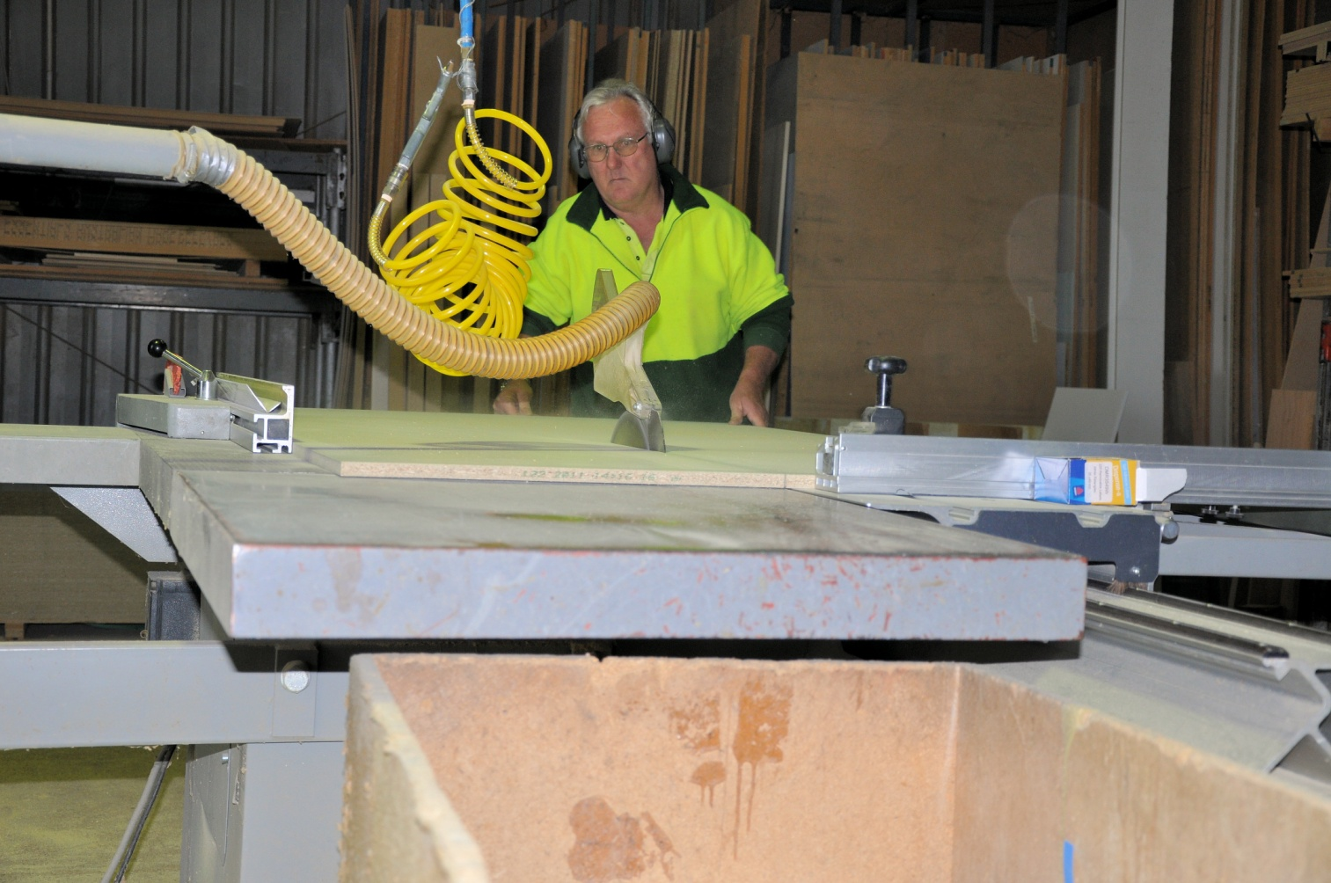Although the basic functions of kitchens and bathrooms haven’t changed for a long time, designs and product features certainly have. This is largely due to technological advancements in both materials and manufacturing processes.

Over the years, a range of ‘engineered’ wood products have been developed, including particleboard, medium density fibreboard (MDF) and plywood. Various synthetic veneers, such as melamine and plastic-based laminates, have also been developed. And there have been many design innovations in hinges, drawer slides and other hardware items.

The tools and equipment used by cabinetmakers have also evolved over the years. Most workshops now have some form of computer numerical controlled (CNC) machinery. There are also specific tools and processes required to work with the materials and specialist hardware items now commonly used.

In this section, we’ll look at the main materials and construction methods and provide a brief overview of the way they have developed over the years.

### Completing this section

The assignment for this section asks you to describe four tools or machines that you use at work and explain their main functions. Have a look at *Assignment 3* on page 44 to see what you’ll need to do to complete it.

There are three lessons for this section:

* *Changing designs*
* *Cabinet construction*
* *Materials and processes*

These lessons will provide you with background information relevant to the assignment.

|  |
| --- |
| Changing designs |

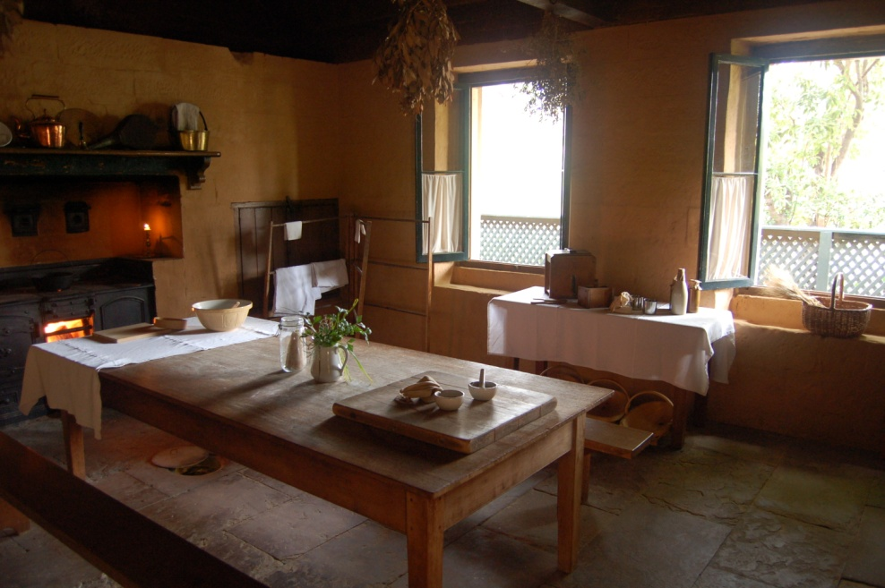Built-in kitchen cabinets are a 20th Century invention. Before World War I (1914-1918), kitchens typically contained a large table in the middle of the room and free standing cupboards or shelves against the walls. In fancier homes the dishes were often stored in the dining room.

In the 1920s and 30s, kitchen designs were influenced by ‘time and motion’ studies carried out by industrial psychologists. Designers looked for more efficient layouts that saved time and effort. Built-in cabinets became more popular, and manufacturers   
improved their processes in making prefabricated units.

After World War II (1939-45) laminates such as Formica were developed in the USA. This brought in the flush surface look of modern kitchens, and cabinets became more ‘minimalist’ in design.

### Modern kitchens

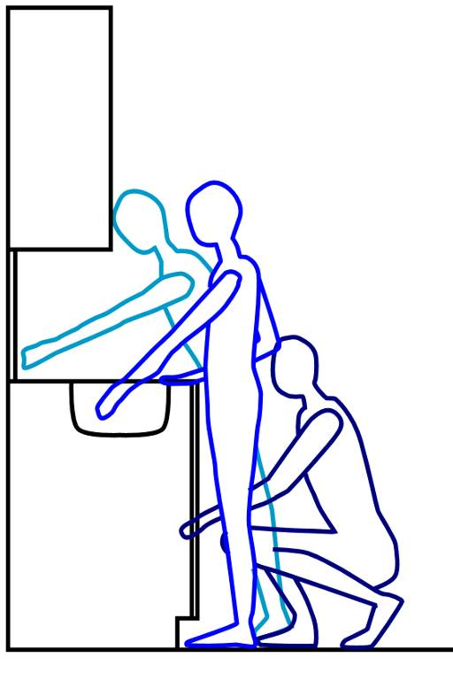In recent years, kitchens have become much more varied in both size and design. Their size has often expanded in larger houses, particularly those built by project home companies. But in apartments and flats they have become more economical and compact.

Modern designs put a lot of emphasis on ‘functionality’ – that is, how efficient and easy-to-use the features are. This approach has been very influenced by studies into **ergonomics**, which has examined the way people move around the kitchen and carry out various functions. An understanding of ergonomics has helped designers to put surfaces, drawers, shelves and controls at the best heights and positions to reduce bending, stretching and other unnecessary movements.

### Health and environmental concerns

Over the last couple of years there has been an increasing interest in health and air quality in buildings. With the widespread use of melamine-faced particleboard and medium density fibreboard (MDF), the chemicals released by formaldehyde glues has become more of an issue. This especially applies in kitchens that have controlled air flow through central heating and air conditioning.

Related to this is the general public’s awareness of environmental care and sustainability. Some materials are now known to use damaging production processes during their manufacture. Others products use certain species of timber that are no longer plentiful in supply. As a result, many clients now ask whether a product is eco-friendly, or ‘green’, before they make a decision on whether to use it.

##### Learning activity

See if you can list 5 different features of modern kitchens that have been designed with ergonomics in mind. You may want to look at your own kitchen for ideas, or check out a company showroom, or even examine the features in a kitchen you’re installing.

Once you’ve named each feature, state what its ergonomic benefits are. Here’s some examples of features to help get you started:

* Pull-out shelves
* Pull-out garbage container
* Lazy susan in a corner cabinet
* Share your answers with your trainer and other learners in the group.

|  |
| --- |
| Cabinet construction |

Cabinets are basically six-sided boxes, closed in on five sides. Two main methods have been used over the years to build the cabinet box, or **carcase**. They are referred to as **face frame** and **frameless** construction. Let’s look at each of these in turn.

### Face frame cabinets

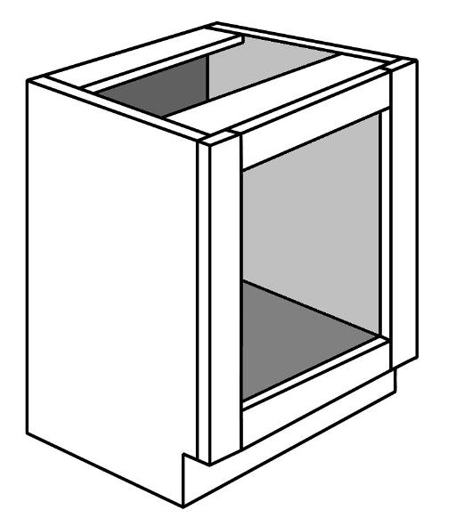The traditional method of construction was to put a solid timber frame, often 38 mm in width, around the face of the opening. The frame helped to keep the cabinet square and also provided a fixing point for the door hinges. On large custom-made cabinets, a single carcase could be divided into several sections, with upright **stiles** in between.

However, if the cabinets were manufactured as stock items, they were likely to be made in more manageable sizes and joined together to achieve the length needed.

### Frameless cabinets

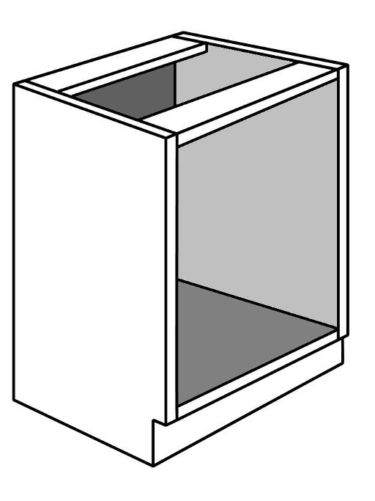**Frameless cabinets** were originally developed in Europe after World War II, when solid timber was hard to get and particleboard was just starting to be produced. By fixing the particleboard panels to each other to form the carcass, and using door hinges that fixed internally, cabinetmakers no longer needed a face frame. The result was the frameless cabinet, also called the **full access** or **European style** cabinet.

The frameless design provided more access space to the cabinet, because the side thickness was only 19 mm. It also allowed prefabricated cabinets to be joined together without losing the extra space taken up by a double stile. And it provided a streamlined look with more modern features, such as cup hinges and drawer slides.

##### Learning activity

The face-frame design is still used in some modern cabinets, particularly when they have timber panelled doors. But the hinges are different from those used in frameless cabinets.

Name at least three different types of hinges used on face-frame cabinet doors. Also describe the way they are fixed to the frame and the door.

Share your answers with your trainer and other learners in the group. You can include digital photos that you’ve taken with your camera or mobile phone if you wish.

|  |
| --- |
| Materials and processes |

There’s a wide range of materials used in kitchen and bathroom cabinet construction. The choices your client makes will depend on the appearance and quality they’re looking for and, of course, their budget.

Below are the main materials used in cabinet carcases, doors and drawers.

### Solid timber

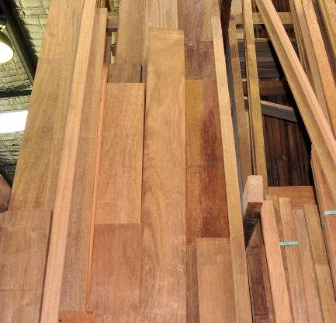Solid timber has prestige. But it’s also expensive, particularly when high grade hardwoods are used. These days, solid timber is generally limited to doors, drawer fronts, bench tops and other parts that are in full view.

Timber framework in cabinet doors is generally made up of pieces joined with dowels, biscuits or mortice and tennon joints. The centre panel is typically in laminated timber, plywood, MDF or glass.

One of the big advantages of working with solid timber is that it can easily be routed and shaped on the edge, without the need for any special finishing or edge stripping. CNC (computer numerical controlled) routers are often used for cutting the profile, especially when it is also being shaped to a curve.

### Particleboard

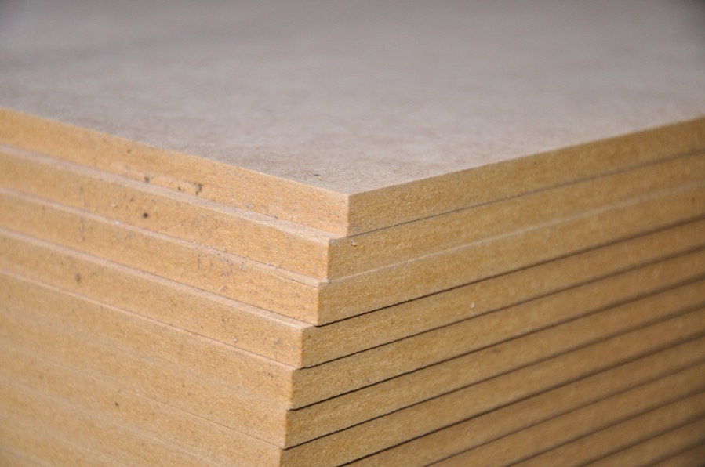Particleboard, also called **chipboard**, is made of wood particles bonded together with a synthetic resin. It is very stable and has reasonable strength when used as panelling and shelving, as long as it is properly supported.

**Standard** (STD) particleboard is bonded with urea formaldehyde glue. This makes the boards economical to produce and provides a consistent density for holding screws and nails. However, it’s not water resistant, and if the board gets wet it will ‘blow up’ or swell.

**Moisture resistant** (MR) particleboard uses melamine formaldehyde and other resins to produce a board that can withstand high humidity and occasional wetting. The board has a greenish tinge, and is most often used in kitchens and bathroom cabinets.

**Melamine faced** particleboard has a melamine veneer on the surface, which provides even more protection to the board underneath. Once the boards are cut to size, they can also be edge-stripped with melamine or solid timber. White melamine is the most popular veneer for internal carcases and shelving, and is often simply called **whiteboard**.

Other veneers are also commonly used on a particleboard **substrate**. When the installation contains solid timber doors, the outside surfaces of the particleboard carcase are often faced with a matching timber veneer. Alternatively, plastic laminates can be used throughout for the doors, carcase and bench tops.

### Medium Density Fibreboard (MDF)

Like particleboard, MDF is also made of wood particles bonded together with formaldehyde resin. It is also available in standard and moisture resistant grades, and can be faced with different veneers.

However, the particles are smaller and more tightly packed together. This means that the edge and face can be machined to a profile without the surface crumbling. The finished panel can then be coated with a flexible veneer or painted.

### Plywood

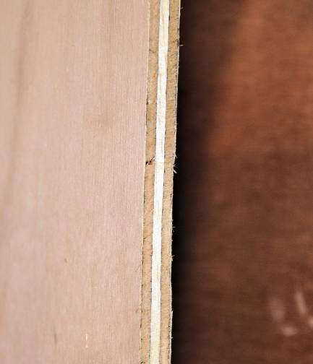Plywood is made of thin sheets of timber veneer bonded together with formaldehyde resin. Every second veneer is laid with the grain running at right angles to the layers above and below. This is what makes plywood strong in all directions, and able to be nailed close to the edge without splitting.

Because plywood is dearer than particleboard and MDF, it isn’t normally used in the carcase unless its high strength is needed. However, it is commonly used as drawer bottoms and in other applications when a thin strong panel is required.

##### Learning activity

The different materials discussed above have different nail-holding and screw-holding abilities. This will affect your choice of fasteners and the methods you use to join boards.

Choose two of the materials that require different joining techniques because of their differences in screw and nail holding properties. Answer the following questions for each material.

* What type of material is it?
* What type of fastener (or fasteners) do you use with this material?
* What tools are required to work with these fasteners?
* Why are these fasteners the most suitable for this material – that is, why wouldn’t other fasteners do the same job?

Share your answers with your trainer and other learners in the group. You can include digital photos that you’ve taken with your camera or mobile phone if you wish.

|  |
| --- |
| Assignment 3 |

Choose one kitchen or bathroom cabinet design that you use regularly at work. Answer the following questions, using the table provided in the linked Word document to set out your answers.

1. **Method of construction:** Is it face-frame or frameless?
2. **Carcase structure:**

* What materials are used in the carcase (e.g. white melamine-faced particleboard)?
* What types of joins are used between the boards in the carcase (e.g. dowelled butt joints)?
* What fixings are used to hold the carcase together (e.g. dowels with PVA glue)?
* What tools are required to construct the cabinet (e.g. panel saw, drill press, etc.)?

1. **Doors:**

* What materials are used in the doors?
* What types of hinges are used?
* How are the hinges fixed to the door and the cabinet?
* What tools are required hinge the doors?

Take digital photos of the cabinet at various stages of completion, showing the construction methods, materials and hardware used and tools required.

**Completing this assignment**

You will find a hard-copy template for this assignment in your Workbook. There is also an electronic version of the template on the website. See the *Introduction* (page 1) for more details on how to access this file.



# Section 4

# Quality elements

|  |
| --- |
| Overview |

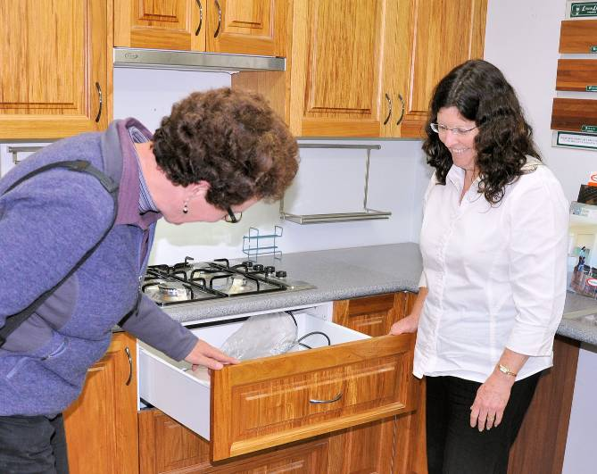A good quality product is one that meets the customer’s expectations and the industry standards that apply to it. Kitchen and bathroom projects are the same. Your clients want to know that they’re getting an installation that will live up to their requirements and be good value for money. They’ll also expect it to comply with all the relevant regulations, building codes and standards.

So how do you keep pace with industry developments, new products on the market and customer expectations? The answer is to stay informed and be attuned to your clients’ needs.

In this section, we’ll look at some of the main factors involved in maintaining quality. We’ll discuss ways of staying up-to-date with the latest information, getting a good deal with your suppliers, and making sure that your client is happy with the work you’ve done for them.

### Completing this section

The assignment for this section is designed to help you find resources that contain the latest information on industry trends, regulations and other details relevant to your work. Have a look at *Assignment 3* on page 57 to see what you’ll need to do to complete it.

There are four lessons for this section:

* *Finding information*
* *Supply sources*
* *Standards*
* *Quality inspection.*

These lessons will provide you with background information relevant to the assignment.

|  |
| --- |
| Finding information |

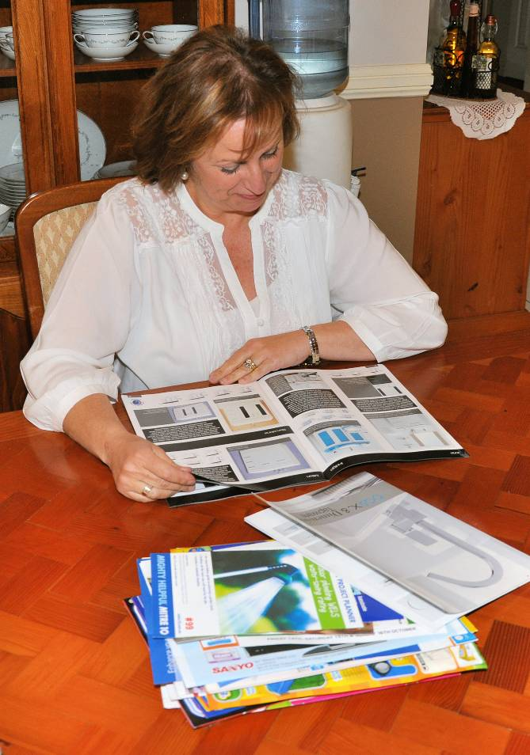There’s no shortage of publications on kitchens and bathrooms. Your local newsagent will have magazines ranging from design ideas to DIY (do-it-yourself) manuals. Building and hardware suppliers will have brochures from manufacturers of plumbing fixtures, appliances, cabinets and other components. Your own company may produce brochures on the products that you handle.

You’ll also find textbooks, information bulletins and instruction manuals published by various industry associations. The Housing Industry Association (HIA), for example, produces a range of texts relating to kitchen and bathroom construction. The consumer organisation, Choice, also publishes reviews of the latest products coming onto the market.

There are many displays and showrooms that exhibit kitchen and bathroom products and designs. Building information centres, manufacturers, retail suppliers and installers generally have showrooms that are open to the public.

When it comes to product safety and safe work practices, there is a vast store of information available from various sources. All products that are classified as ‘hazardous’ are required to have a material safety data sheet (MSDS) produced by the manufacturer. The WorkCover authority in your state or territory will also have a range of publications, guidelines and news alerts that are relevant to your work as a cabinetmaker.

##### Learning activity

Apart from the print publications available, you’ll find an endless supply of information on the web. Just type ‘kitchens’, ‘bathrooms’, ‘kitchens and bathrooms’, or any other relevant key words into your search engine.

Below are some organisations that have websites containing specific information relating to kitchen and bathroom projects. You can find each one by typing the relevant name into your search engine.

* Housing Industry Association of Australia (look for the link that takes you to the Kitchen and Bathroom area of the website)
* WorkCover (remember to specify the state or territory you are in)
* Your local council.

|  |
| --- |
| Supply sources |

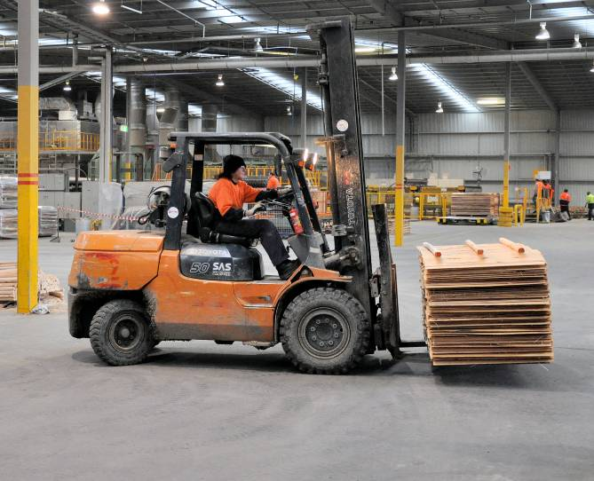Every successful business needs reliable suppliers. Without them, your business would quickly grind to a halt even if you had a book full of customer jobs.

There is more to reliability than being able to deliver the materials you’ve asked for on time. The supplier also needs to maintain a consistent quality in the materials it provides, as well as prices that are competitive and stable over time.

Most kitchen and bathroom businesses have several main suppliers and a range of back-up suppliers. There are advantages in showing loyalty to your main suppliers, such as receiving good credit terms and discounted prices. But it’s essential to have alternative suppliers on hand, just in case your main stockist isn’t able to deliver a particular product when you need it.

Below are some of the factors you should consider when you’re building up your group of suppliers:

* Do the main suppliers have strong links with the manufacturers (or are they the manufacturers of the products themselves)?
* Do they keep large stock holdings, with materials available at short notice?
* Do the brand names have a good reputation for quality?
* Are the prices competitive, and are you given plenty of notice before a price rise?
* Do the prices include delivery charges and do they apply to different order volumes?
* Are the staff helpful if there is a problem, and do they offer refunds or credit for returned stock?
* Do you have at least one back-up supplier for each material or product you need?

##### Learning activity

Make a list of five suppliers to your company. Write beside each one the main products they supply to you.

Now draw up a set of questions that you would ask to evaluate these suppliers. You may use the questions above, or include new ones if there are other factors that need to be considered.

Ask your supervisor or manager for help with this activity if you need more information. Share your answers with your trainer and other learners in the group.

|  |
| --- |
| Standards |

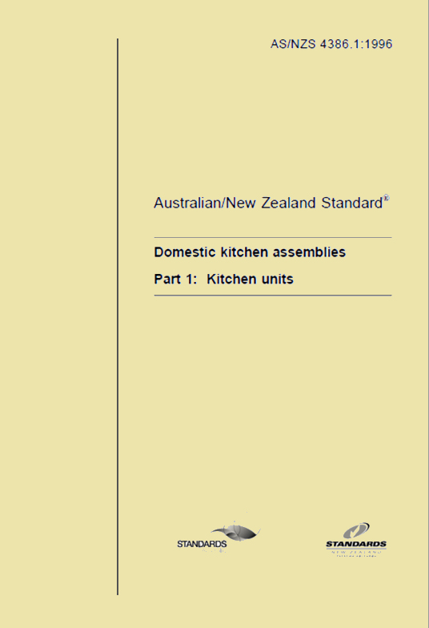Standards are reference documents that set out ‘benchmark’ specifications and descriptions. These benchmarks are used to check that an approved level of quality or performance is being achieved.

There are different types of standards, depending on the product or service being described.

Some companies develop their own standards, and call them by trademarked names. This type of standard is called an ‘enterprise standard’, because it only applies to the enterprise that developed it.

Other standards are developed by recognised bodies that consult with industry people, end users and government authorities. The two organisations most prominent in Australia are:

* Standards Australia, which produces the Australian Standards (prefixed with 'AS')
* International Organization for Standardization, which produces International Standards (prefixed with 'ISO').

Another type of standards document used by people involved in building is the Building Code of Australia (BCA). This document sets out the technical requirements for all areas of building, from design through to construction. It is produced by the Australian Building Codes Board, and has many cross references to particular Australian Standards.

When these standards are referred to in contracts for work to be performed, they become legally binding. This means that if your contract with a client says that you will comply with AS/NZS (Australian Standard / New Zealand Standard) 4386.1: *Domestic kitchen assemblies*, then you are required by law to meet the specifications contained in that standard.

### Some common industry standards

Sometimes people use the term ‘standard’ to simply refer to common ways of doing things. These sorts of standards are not formal requirements, but just ‘good practice’ accepted by the industry. They only become legally binding when you state the actual measurements into your specification document.

Below are some common ‘industry standards’ for kitchen cabinet dimensions. You’ll see that the measurements have a plus (+) and minus (-) **tolerance** for each figure. For more details on how these tolerances work, see the *Learning activity* below*.*

**Kickboard height:** 150 mm + 50 mm

**Bench top height:** 900 + 20 mm

**Floor unit height:** 720 + 1 mm – 4 mm (not including kickboard)

**Floor unit depth:** 580 (door handles excluded)

**Wall unit height:** 720 + 1 mm – 4 mm

**Wall unit depth:** up to 350mm (door handles excluded)

**Splashback height above sink:** 450 mm minimum, or 600 mm if there is a wall unit above

**Splashback height above electric cook top:** 600mm minimum

##### Learning activity

You will often see measurements in standards showing ‘tolerances’, or plus (+) and minus (-) figures. This means that the measurement can vary up or down by the tolerance allowed and still be within the standard.

For example, if a standard kickboard height is listed as: 150 mm + 50 mm, then it can range between:

150 + 50 = 200 mm

150 – 50 = 100 mm.

What are the maximum and minimum measurements for the following two industry standards? Use the measurements from the list above to calculate your answers.

* **Bench top height**
* **Floor unit height**

Check your answers with your trainer and other learners in the group.

|  |
| --- |
| Quality inspection |

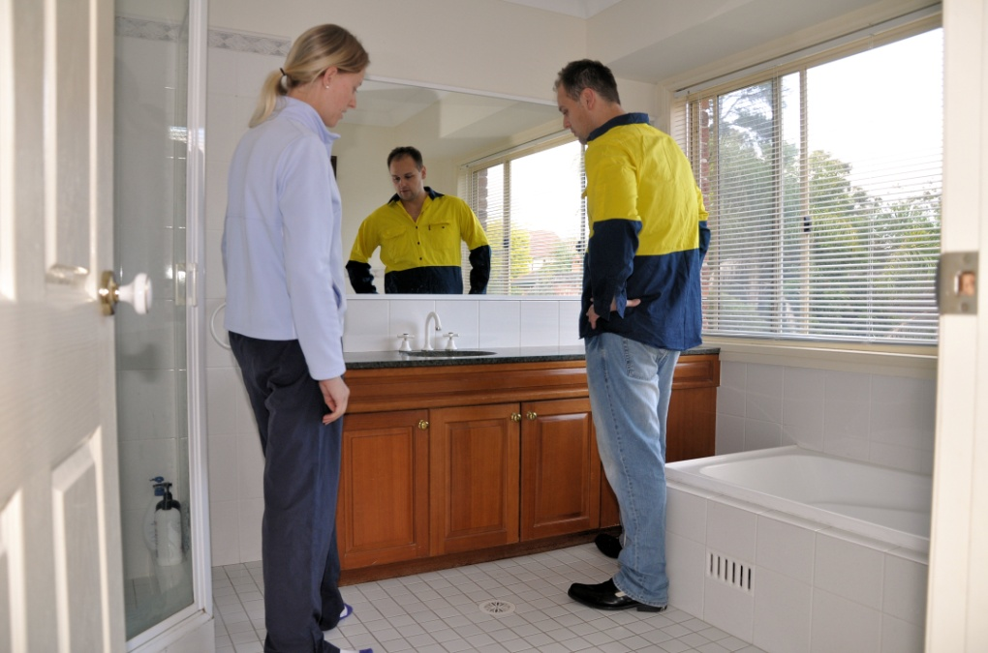Once everyone has completed their work and you’ve put the finishing touches on the project, it’s time to get paid for the installation job. But before you can do that, the client will want to do a final quality inspection with you to check that everything is right.

Naturally, the best client to deal with is one who is 100% satisfied with your work. They not only pay their bills on time, they also give you good word-of-mouth recommendations to others. So it’s important that you’ve made sure everything is in order before you do the final walk through.

Below is a checklist of some of the things to look for before you organise a final inspection with the client.

### Pre-inspection checklist

Check that:

* Doors and drawer fronts have even margins
* Drawer runners are smooth and drawer fronts close evenly
* Door and drawer handles are fitted
* Adjustable shelves are in place
* Screws have been capped in all carcasses
* Exposed ends of kickboards have been edged
* Accessories have been fitted and are operating correctly
* Bench tops are secure and cut outs have been sealed
* Sink is properly secured and sealed
* Doors, drawer fronts and end panels have been cleaned
* Cabinet interiors are clean
* All rubbish has been removed.

##### Learning activity

Depending on the type of job you’re doing, there may be other things you also need to check before you organise a final walk through with the client. Can you think of any other items?

Write up a list of any remaining items that you would need to check on a particular kitchen or bathroom project.

Share your list with your trainer and other learners in your group.

|  |
| --- |
| Assignment 4 |

Find one example of each of the following resources relevant to your own work:

* Industry or trade magazine
* Textbook or instruction manual
* Manufacturer’s brochure
* Building or furnishing association
* WorkCover authority in your state or territory

Write up the following information for each one, using the table provided in the template from your Workbook:

1. Title of the publication or website
2. Where you gained access to it – that is, did you get it from the manufacturer, from your own company, from a bookshop, via the internet, etc (if it’s a website, state the web address)
3. Brief description of the resource, including its relevance to your own work.

**Completing this assignment**

You will find a hard-copy template for this assignment in your Workbook. There is also an electronic version of the template on the website. See the *Introduction* (page 1) for more details on how to access this file.