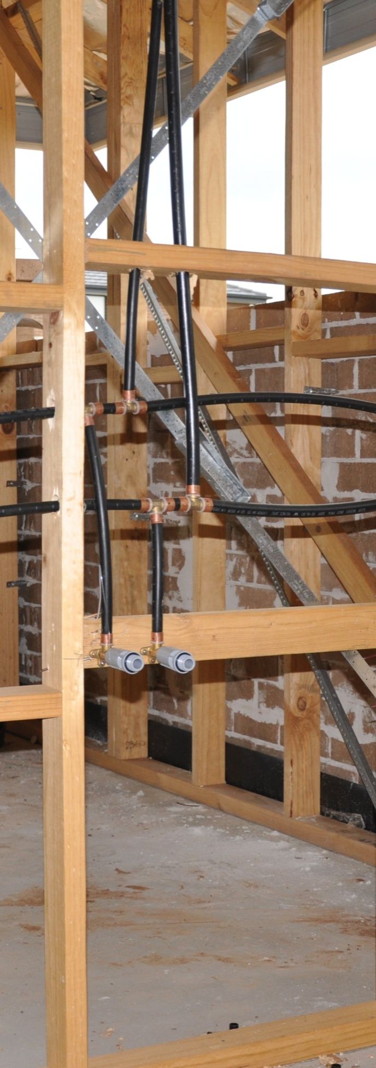

Installation requirements

**Supporting:**

***LMFKB3002A  
Determine requirements for installation of cabinets***

**Work book**

**Developed in 2011-2012 for the WELL Program**

DRAFT VERSION

October 11

Installation requirements

Workbook

Containing print-version written assignments supporting the unit of competency:

***LMFKB3002A Determine requirements for installation of cabinets***

These assignments are also available in an electronic ‘Word’ version, downloadable from the Kitchen and Bathroom Cabinetmaking website at:

[www.kbcabinetmaking.com.au](http://www.kbcabinetmaking.com.au)



Developed by Workspace Training for the 2011-2012

Workplace English Language and Literacy (WELL) Program

Kitchen and Bathroom Cabinetmaking resource development project



[www.workspacetraining.com.au](http://www.workspacetraining.com.au)

ISBN: 978-0-9873328-6-8

Funded under the Workplace English Language and Literacy Program by the Australian Government through the Department of Education, Employment and Workplace Relations.

COPYRIGHT

© Commonwealth of Australia. 2012



CC BY-NC-SA

This work is copyright. Except where otherwise indicated, and save for the Commonwealth Coat of Arms, the Department has applied the Creative Commons Attribution-Noncommercial-Share Alike 3.0 Australia Licence to this work.

The Department of Education, Employment and Workplace Relations must be attributed as the author of the Department’s copyright material.

As far as practicable, material for which the copyright is owned by a third party has been clearly labelled. The Department has made all reasonable efforts to ensure that this material has been reproduced in this print-based resource and the accompanying website with the full consent of the copyright owners.

Requests and enquiries concerning the Department’s copyright material should be addressed to:

The Copyright Officer   
Department of Education, Employment and Workplace Relations   
Location code C148CW2   
GPO Box 9880 Canberra ACT 2601   
Email: [copyright@deewr.gov.au](mailto:copyright@deewr.gov.au)

Questions about the design and content of the resource itself should be addressed to the project manager:

David McElvenny  
Workspace Training  
PO Box 1954 Strawberry Hills, NSW, 2012   
Email: [david@workspacetraining.com.au](mailto:david@workspacetraining.com.au)

# Table of contents

The assessment process 1

Completing the assignments 3

Assignment 1 4

Assignment 2 5

Assignment 3 6

# The assessment process

Kitchen and bathroom cabinetmaking is a practical trade that requires good hands-on skills and a sound knowledge of construction methods. Your assessor will use a range of methods to assess your ‘competence’ in the units that make up this qualification.

These may include:

* on-the-job discussions about how you go about particular workplace activities
* learning activities undertaken while you’re progressing through the unit
* practical demonstrations of your ability to use certain pieces of equipment competently and safely
* examples of products you have made and documents you have completed
* written assignments contained in the Workbooks.

The assignments contained in this Workbook are only a part of the overall assessment process for the unit. However, they are an essential part, because they allow you to demonstrate your understanding of the concepts and principles behind the skills involved.

Your assessor will talk to you about the other activities and practical demonstrations you’ll need to carry out and the timetable for completion.

### Literacy and numeracy skills

Literacy is the ability to read and write. To complete this trade qualification, you will need sufficient literacy skills to fill in forms and other types of workplace documents correctly. You will also need the skills to be able to read and understand workplace documents such as order sheets, project briefs and safe operating procedures.

Numeracy is the ability to work with numbers. Cabinetmakers need to do lots of calculations with measurements and quantities, so there will be many opportunities for you to learn and practice your numeracy skills.

When it comes to completing the written assignments for this qualification, a certain level of literacy ability is required to read the questions and write down your answers. Obviously, it’s important that you clearly understand what the assignment is asking you to do, and that your answers are a good reflection of what you really know. So if you’re having trouble reading the questions or writing down your answers, make sure you speak to your trainer before you hand the assignment in.

There are various ways your trainer can help you. For example, they may be able to ask the assignment questions verbally and help you to write down your answers. They may also be able to show you sample answers to similar questions, which will let you look at the way they’re written and give you hints on how to write your own. You may also be allowed to do the assignment with the assistance of another person.

### Applying for RPL

RPL stands for **Recognition of Prior Learning. It is a** form of assessment that acknowledges the skills and knowledge you have gained through:

* on-the-job experience
* formal training in other courses
* life experience, through your hobbies or other outside activities.

If you believe that you are already competent in some or all of the skills covered in this unit, ask your assessor about how to apply for RPL.

You’ll find an RPL checklist for this unit on the Kitchen and Bathroom Cabinetmaking website.

# Completing the assignments

There are three assignments for the unit *Installation requirements*.

These are shown on the following pages, in a layout suitable for hand-written answers. You should detach each assignment from the workbook when you have finished it and hand it to your trainer for marking.

If you prefer to complete the assignments on your computer, go to the website version of this unit and look for the *Assignment* link in each of the three sections. This will allow you to save your answers in an electronic file, which can either be printed out as a hard copy or emailed direct to your trainer as an attachment.

Before you begin each assignment, make sure you read the information in the Learner Guide or on the website for this unit. You’ll find a page relating to the assignment that summarises the questions and provides extra material and pointers to help you complete them.

|  |
| --- |
| Assignment 1 |

Below is a 3D view of a kitchen. Your task is to provide simple line drawings of the kitchen in the following views:

* front elevation of the wall containing the window.
* plan view of the room, showing the floor cabinets only.

There is no need to mark in any dimensions, but try to keep the scale as accurate as possible.

You may do the drawings by hand or on a computer. If you use a pen and paper, you should either use graph paper or a blank page and ruler. If you use a computer, there is no need for a specialised drawing program – you can use any simple program that generates lines and shapes.

Note that the objective of this assignment is to practise ‘seeing’ different views of a room in your mind’s eye – it’s not to produce architectural drawings. This ability to do simple sketches of a room is a skill that you will use constantly when you carry out site assessments and prepare cabinets for installations.

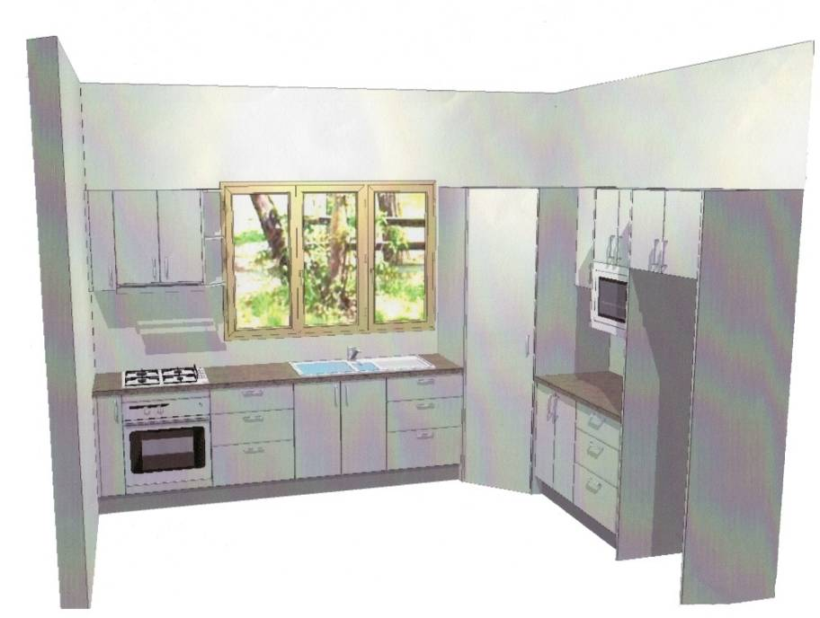

### Completing this assignment

Note that there is no template page for this assignment. If you are producing your drawings in hard copy, you should slide the separate pages into this workbook. Don’t forget to put your name and details on the top of the page.

|  |
| --- |
| Assignment 2 |

|  |  |  |  |
| --- | --- | --- | --- |
| Name |  | Date |  |

The drawing below shows a section through a building.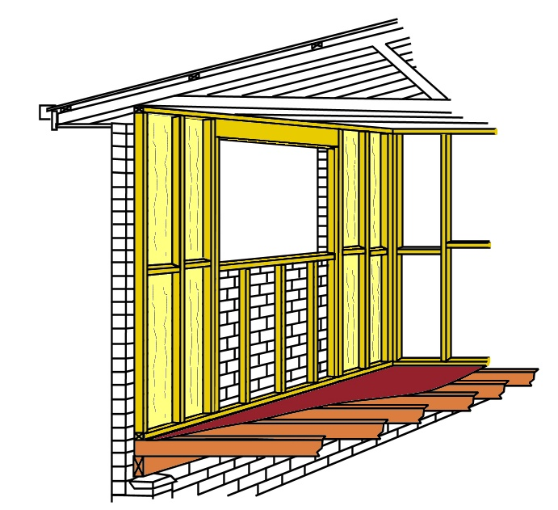

### 1

2

3

4

5

6

7

1. Name each of the parts that are numbered

|  |  |
| --- | --- |
| 1 | 2 |
| 3 | 4 |
| 5 | 6 |
| 7 |  |

2. What type of wall structure does this drawing represent?

|  |
| --- |
|  |
| Assignment 3 |

|  |  |  |  |
| --- | --- | --- | --- |
| Name |  | Date |  |

Let’s assume that you’re going to renovate the kitchen or bathroom in your own home, or in the home of a friend or relative. Your task is to carry out a site assessment and collect the information you’ll need to prepare for the project.

For this assignment, there is no need to take detailed measurements on the positions of power and water outlets, or to check floor levels and wall angles.

When you have completed the checklist, take several digital photos of the kitchen or bathroom to submit as part of the assignment.

### Site assessment checklist

### Room

**1.** **Type**: State the room that this site assessment is being carried out on – e.g. kitchen, main bathroom, ensuite bathroom.

|  |
| --- |
|  |

**2.** **Plan:** Sketch a plan view of the room, showing all doorways and windows. Mark the lengths of the walls, as well as door and window openings.

Note that there is no need to show cabinets, appliances or other installations on the plan. For the purposes of this exercise, we will assume that all fittings will be removed as part of the renovation.

You may draw the plan in the space on the following page, or attach a separate page to this assignment.

Plan view of room

### Floor

**3. Sub-floor structure**: Describe the sub-floor – e.g. concrete slab on ground, suspended concrete slab, timber joists with particle board sheet flooring.

|  |
| --- |
|  |

**4. Floor covering**: Describe the floor covering – e.g. solid timber strip flooring, cork tiles, vinyl tiles, ceramic tiles.

|  |
| --- |
|  |

### Walls

**5. Wall structure**: Describe the internal wall construction – e.g. cement render on brickwork, timber frame lined with gyprock.

|  |
| --- |
|  |

**6. Wall finish**: Describe the surface and finish – e.g. ceramic tiles fixed to villaboard, painted gyprock, painted cement render.

|  |
| --- |
|  |

**7. Windows**: Describe the type of windows – e.g. timber, aluminium.

|  |
| --- |
|  |

### Ceiling

**8. Ceiling structure**: Describe the ceiling structure – e.g. gyprock fixed to timber joists, suspended concrete slab.

|  |
| --- |
|  |

### Electricals

**9. Lights**: State the number and types of lights – e.g. one double fluorescent fitting in middle of ceiling, 4 recessed down lights in ceiling.

|  |
| --- |
|  |

**10. Power points**: State the number and location of power points – e.g. two double power points over bench top plus one single power point under sink (for dishwasher), one double power point inside vanity cabinet.

|  |
| --- |
|  |

### Plumbing

**11. Outlets**: State the number and types of outlets – e.g. hot and cold outlets over kitchen sink plus cold outlet under bench top for dishwasher.

|  |
| --- |
|  |

**12. Wastewater**: Describe the number and types of wastewater pipes – e.g. one sink/dishwasher, one vanity basin plus two floor wastes plus one toilet.

|  |
| --- |
|  |

### Hazardous substances

**13. Hazardous substances**: State whether you think there might be any hazardous substances, such as asbestos fibro wall linings or lead-based paint

|  |
| --- |
|  |

### Site access

**14. Room location**: Describe the room location in the building – e.g. ground floor at rear of the house, adjoining the living room in a second floor apartment.

|  |
| --- |
|  |

**15. Room access:** Describe the access way, and any issues that might cause a problem – e.g. direct access from backward through rear sliding door (900 mm wide), access through two flights of stairs with middle landing (900 mm wide).

|  |
| --- |
|  |

**16. Vehicle access:** Describe the access for delivery trucks and tradespeople’s vehicles – e.g. side driveway with plenty of parking at rear of house, street parking only with 2 hour limit.

|  |
| --- |
|  |