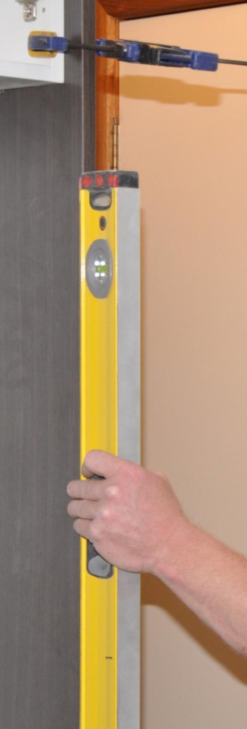

**Supporting:**

***LMFKB3003A  
Check and measure fit of cabinets***

Checking fit of cabinets

**Work book**

**Developed in 2011-2012 for the WELL Program**

DRAFT VERSION

October 11

Checking fit

of cabinets

Workbook

Containing print-version written assignments supporting the unit of competency:

***LMFKB3003A Check and measure fit of cabinets***

These assignments are also available in an electronic ‘Word’ version, downloadable from the Kitchen and Bathroom Cabinetmaking website at:

[www.kbcabinetmaking.com.au](http://www.kbcabinetmaking.com.au)



Developed by Workspace Training for the 2011-2012

Workplace English Language and Literacy (WELL) Program

Kitchen and Bathroom Cabinetmaking resource development project



[www.workspacetraining.com.au](http://www.workspacetraining.com.au)

ISBN: 978-0-9873328-7-5

Funded under the Workplace English Language and Literacy Program by the Australian Government through the Department of Education, Employment and Workplace Relations.

COPYRIGHT

© Commonwealth of Australia. 2012



CC BY-NC-SA

This work is copyright. Except where otherwise indicated, and save for the Commonwealth Coat of Arms, the Department has applied the Creative Commons Attribution-Noncommercial-Share Alike 3.0 Australia Licence to this work.

The Department of Education, Employment and Workplace Relations must be attributed as the author of the Department’s copyright material.

As far as practicable, material for which the copyright is owned by a third party has been clearly labelled. The Department has made all reasonable efforts to ensure that this material has been reproduced in this print-based resource and the accompanying website with the full consent of the copyright owners.

Requests and enquiries concerning the Department’s copyright material should be addressed to:

The Copyright Officer   
Department of Education, Employment and Workplace Relations   
Location code C148CW2   
GPO Box 9880 Canberra ACT 2601   
Email: [copyright@deewr.gov.au](mailto:copyright@deewr.gov.au)

Questions about the design and content of the resource itself should be addressed to the project manager:

David McElvenny  
Workspace Training  
PO Box 1954 Strawberry Hills, NSW, 2012   
Email: [david@workspacetraining.com.au](mailto:david@workspacetraining.com.au)

# Table of contents

[The assessment process 1](#_Toc320191631)

[Completing the assignments 3](#_Toc320191632)

[Assignment 1 5](#_Toc320191633)

[Assignment 2 7](#_Toc320191634)

# The assessment process

Kitchen and bathroom cabinetmaking is a practical trade that requires good hands-on skills and a sound knowledge of construction methods. Your assessor will use a range of methods to assess your ‘competence’ in the units that make up this qualification.

These may include:

* on-the-job discussions about how you go about particular workplace activities
* learning activities undertaken while you’re progressing through the unit
* practical demonstrations of your ability to use certain pieces of equipment competently and safely
* examples of products you have made and documents you have completed
* written assignments contained in the Workbooks.

The assignments contained in this Workbook are only a part of the overall assessment process for the unit. However, they are an essential part, because they allow you to demonstrate your understanding of the concepts and principles behind the skills involved.

Your assessor will talk to you about the other activities and practical demonstrations you’ll need to carry out and the timetable for completion.

### Literacy and numeracy skills

Literacy is the ability to read and write. To complete this trade qualification, you will need sufficient literacy skills to fill in forms and other types of workplace documents correctly. You will also need the skills to be able to read and understand workplace documents such as order sheets, project briefs and safe operating procedures.

Numeracy is the ability to work with numbers. Cabinetmakers need to do lots of calculations with measurements and quantities, so there will be many opportunities for you to learn and practice your numeracy skills.

When it comes to completing the written assignments for this qualification, a certain level of literacy ability is required to read the questions and write down your answers. Obviously, it’s important that you clearly understand what the assignment is asking you to do, and that your answers are a good reflection of what you really know. So if you’re having trouble reading the questions or writing down your answers, make sure you speak to your trainer before you hand the assignment in.

There are various ways your trainer can help you. For example, they may be able to ask the assignment questions verbally and help you to write down your answers. They may also be able to show you sample answers to similar questions, which will let you look at the way they’re written and give you hints on how to write your own. You may also be allowed to do the assignment with the assistance of another person.

### Applying for RPL

RPL stands for **Recognition of Prior Learning. It is a** form of assessment that acknowledges the skills and knowledge you have gained through:

* on-the-job experience
* formal training in other courses
* life experience, through your hobbies or other outside activities.

If you believe that you are already competent in some or all of the skills covered in this unit, ask your assessor about how to apply for RPL.

You’ll find an RPL checklist for this unit on the Kitchen and Bathroom Cabinetmaking website.

# Completing the assignments

There are two assignments for the unit *Checking fit of cabinets*.

These are shown on the following pages, in a layout suitable for hand-written answers. You should detach each assignment from the workbook when you have finished it and hand it to your trainer for marking.

Some of the assignments may be completed electronically on your computer. If you prefer to do this you should go to the website version of this unit and look for the *Assignment* link in each of the two sections. This will allow you to save your answers in an electronic file, which can either be printed out as a hard copy or emailed direct to your trainer as an attachment.

Before you begin each assignment, make sure you read the information in the Learner Guide or on the website for this unit. You’ll find a page relating to the assignment that summarises the questions and provides extra material and pointers to help you complete them.

|  |
| --- |
| Assignment 1 |

### Task 1

Drawing 1 below shows a wall in a kitchen, with hot and cold water pipes and power for the dishwasher power point. The cabinet installer has measured where the services are in terms of the left hand wall and the finishing line (top) of the cabinet carcases. Drawing 2 shows the layout lines for the cabinets, together with their names and width dimensions. Drawing 3 (next page) shows the sink cabinet, viewed from the back.

Work out where the centre points will be for the three holes in the back of the cabinet. Write your answers in the boxes provided on Drawing 3 on the following page.

**Drawing 1**

**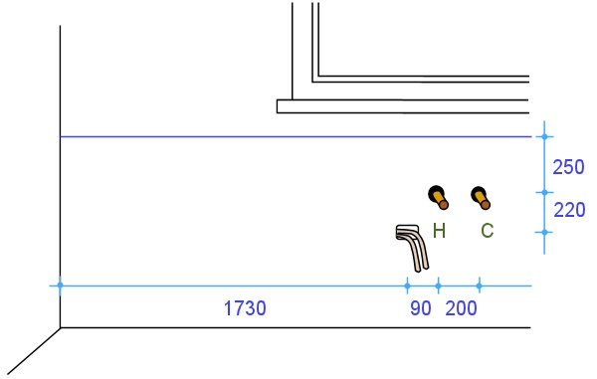**

**Drawing 2**

**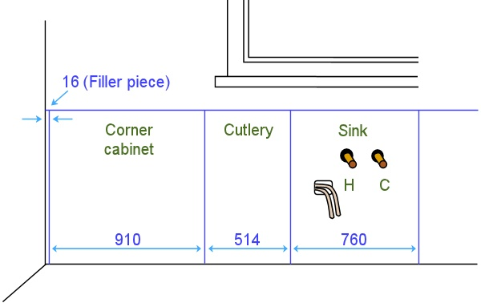**

|  |  |  |  |
| --- | --- | --- | --- |
| Name |  | Date |  |

**Drawing 3**

**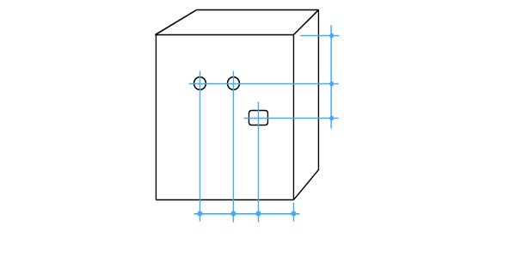**

Note that the positions of these holes are reversed in relation to the view of the wall, because you are looking at the back of the cabinet.

### Task 2

Assume that you have been asked to check all relevant measurements on one wall of a kitchen or bathroom, in preparation for a new installation. Your task is to produce a freehand sketch of that wall in elevation view, showing all required features and measurements.

The wall you choose to draw up may be in a building where you are installing a kitchen or bathroom. Or it may be in your own home or a friend’s home, if you don’t have access to a jobsite. Do not show any existing cabinets or other fittings – you should assume that these will be demolished before the new installation begins.

The wall should include the following features as a minimum: a door, a window and water pipes for taps. It may also include other features, such as power outlets, columns, bulkheads and any other architectural features.

You may use symbols and abbreviations in your elevation sketch, but all details must be clear to others who might need to consult the drawing, and all relevant measurements must be easily identifiable.

### Completing this assignment

Note that there is no template page for Task 2 above. If you are producing your drawings in hard copy, you should slide the separate pages into this workbook. Don’t forget to put your name and details on the top of the page.

|  |
| --- |
| Assignment 2 |

|  |  |  |  |
| --- | --- | --- | --- |
| Name |  | Date |  |

### s2_assignment_1.jpgQuestion 1

You need to measure the width of a room with your tape measure. So you ask your offsider to hold the end of the tape against one wall while you stretch out the tape to the opposite wall.

However, you notice that there is a sag in the tape, because you’re both working at waist height and it is a long room.

(a) What effect will the sag in the tape have on the measurement?

|  |
| --- |
|  |

(b) How can you overcome this problem?

|  |
| --- |
|  |

### s2_assignment_2.jpgQuestion 2

At one end of the room there is a boxed-in section which houses a waste pipe. You need to measure the full length of the room, so your offsider holds the tape beside the boxed-in section while you stretch it across to the far corner.

But when you look back you can see that the tape is not running at right angles to the two walls.

1. What effect will this angle have on the measurement?

|  |
| --- |
|  |

1. State two different ways you could overcome this problem by repositioning the tape. (Hint: one way will occur at your end, and the other way will occur at your off-sider’s end.)

|  |
| --- |
|  |

### Question 3

You have been given an old spirit level that looks a bit knocked around. You place it on the floor and find that the bubble is exactly in the middle of the vial, indicating that the floor is dead level.

But when you turn the level back-to-front and check it again, the bubble is now off centre.

1. Is this level giving you accurate readings?

|  |
| --- |
|  |

1. What should you do with the level?

|  |
| --- |
|  |

### Question 4

What is the commonsense safety precaution to keep in mind when working with a laser level? (Hint: it concerns your eyes.)

|  |
| --- |
|  |