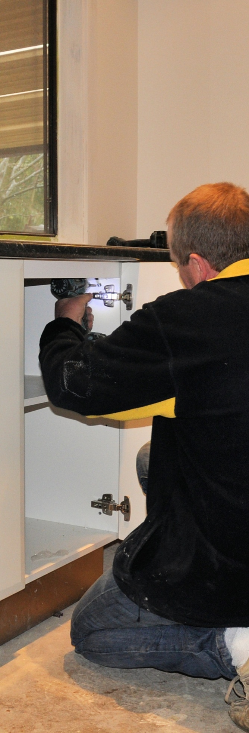

Adjusting cabinets on-site

**Work book**

**Developed in 2011-2012 for the WELL Program**

DRAFT VERSION

October 11



**Supporting:**

***LMFKB3004A  
Conduct on-site adjustments to cabinets and components***

Adjusting

cabinets on-site

Workbook

Containing print-version written assignments supporting the unit of competency:

***LMFKB3004A Conduct on-site adjustment to cabinets and components***

These assignments are also available in an electronic ‘Word’ version, downloadable from the Kitchen and Bathroom Cabinetmaking website at:

[www.kbcabinetmaking.com.au](http://www.kbcabinetmaking.com.au)



Developed by Workspace Training for the 2011-2012

Workplace English Language and Literacy (WELL) Program

Kitchen and Bathroom Cabinetmaking resource development project



[www.workspacetraining.com.au](http://www.workspacetraining.com.au)

ISBN: 978-0-9873328-8-2

Funded under the Workplace English Language and Literacy Program by the Australian Government through the Department of Education, Employment and Workplace Relations.

COPYRIGHT

© Commonwealth of Australia. 2012



CC BY-NC-SA

This work is copyright. Except where otherwise indicated, and save for the Commonwealth Coat of Arms, the Department has applied the Creative Commons Attribution-Noncommercial-Share Alike 3.0 Australia Licence to this work.

The Department of Education, Employment and Workplace Relations must be attributed as the author of the Department’s copyright material.

As far as practicable, material for which the copyright is owned by a third party has been clearly labelled. The Department has made all reasonable efforts to ensure that this material has been reproduced in this print-based resource and the accompanying website with the full consent of the copyright owners.

Requests and enquiries concerning the Department’s copyright material should be addressed to:

The Copyright Officer   
Department of Education, Employment and Workplace Relations   
Location code C148CW2   
GPO Box 9880 Canberra ACT 2601   
Email: [copyright@deewr.gov.au](mailto:copyright@deewr.gov.au)

Questions about the design and content of the resource itself should be addressed to the project manager:

David McElvenny  
Workspace Training  
PO Box 1954 Strawberry Hills, NSW, 2012   
Email: [david@workspacetraining.com.au](mailto:david@workspacetraining.com.au)

# Table of contents

[The assessment process 1](#_Toc320191631)

[Completing the assignments 3](#_Toc320191632)

[Assignment 1 4](#_Toc320191633)

[Assignment 2 7](#_Toc320191634)

# The assessment process

Kitchen and bathroom cabinetmaking is a practical trade that requires good hands-on skills and a sound knowledge of construction methods. Your assessor will use a range of methods to assess your ‘competence’ in the units that make up this qualification.

These may include:

* on-the-job discussions about how you go about particular workplace activities
* learning activities undertaken while you’re progressing through the unit
* practical demonstrations of your ability to use certain pieces of equipment competently and safely
* examples of products you have made and documents you have completed
* written assignments contained in the Workbooks.

The assignments contained in this Workbook are only a part of the overall assessment process for the unit. However, they are an essential part, because they allow you to demonstrate your understanding of the concepts and principles behind the skills involved.

Your assessor will talk to you about the other activities and practical demonstrations you’ll need to carry out and the timetable for completion.

### Literacy and numeracy skills

Literacy is the ability to read and write. To complete this trade qualification, you will need sufficient literacy skills to fill in forms and other types of workplace documents correctly. You will also need the skills to be able to read and understand workplace documents such as order sheets, project briefs and safe operating procedures.

Numeracy is the ability to work with numbers. Cabinetmakers need to do lots of calculations with measurements and quantities, so there will be many opportunities for you to learn and practice your numeracy skills.

When it comes to completing the written assignments for this qualification, a certain level of literacy ability is required to read the questions and write down your answers. Obviously, it’s important that you clearly understand what the assignment is asking you to do, and that your answers are a good reflection of what you really know. So if you’re having trouble reading the questions or writing down your answers, make sure you speak to your trainer before you hand the assignment in.

There are various ways your trainer can help you. For example, they may be able to ask the assignment questions verbally and help you to write down your answers. They may also be able to show you sample answers to similar questions, which will let you look at the way they’re written and give you hints on how to write your own. You may also be allowed to do the assignment with the assistance of another person.

### Applying for RPL

RPL stands for **Recognition of Prior Learning. It is a** form of assessment that acknowledges the skills and knowledge you have gained through:

* on-the-job experience
* formal training in other courses
* life experience, through your hobbies or other outside activities.

If you believe that you are already competent in some or all of the skills covered in this unit, ask your assessor about how to apply for RPL.

You’ll find an RPL checklist for this unit on the Kitchen and Bathroom Cabinetmaking website.

# Completing the assignments

There are two assignments for the unit *Adjusting cabinets on-site*.

These are shown on the following pages, in a layout suitable for hand-written answers. You should detach each assignment from the workbook when you have finished it and hand it to your trainer for marking.

Some of the assignments may be completed electronically on your computer. If you prefer to do this you should go to the website version of this unit and look for the *Assignment* link in each of the two sections. This will allow you to save your answers in an electronic file, which can either be printed out as a hard copy or emailed direct to your trainer as an attachment.

Before you begin each assignment, make sure you read the information in the Learner Guide or on the website for this unit. You’ll find a page relating to the assignment that summarises the questions and provides extra material and pointers to help you complete them.

|  |
| --- |
| Assignment 1 |

|  |  |  |  |
| --- | --- | --- | --- |
| Name |  | Date |  |

### Question 1

Three different types of concealed hinge are shown below. Their names refer to the position of the door in relation to the side of the cabinet.

What is the name of each type of hinge?

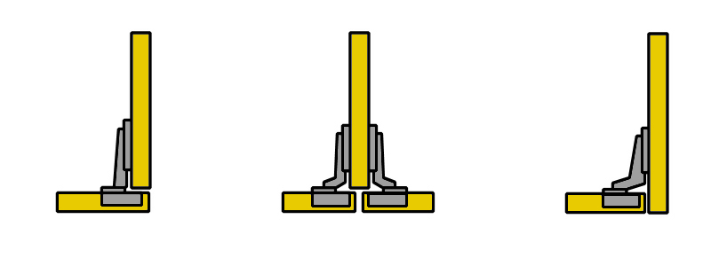

### Question 2

Choose a concealed hinge that you commonly use in your cabinets and answer the following questions:

(a) Who is the manufacturer and what is the full name of the hinge?

|  |
| --- |
|  |

(b) What is the standard gap that you try to achieve between doors?

|  |
| --- |
|  |

(c) How do you fix a bind in the door with this type of hinge?

|  |
| --- |
|  |

### Question 3

Choose a drawer system that you commonly use and answer the following questions:

1. How is the drawer front fixed to the drawer? If it uses a patented system, name the manufacturer and the product. If is a standard workshop-built drawer, describe the process for fixing the front.

|  |
| --- |
|  |

1. If a drawer front was high on one side in the finished cabinet, how would you drop that side so the front was level?

|  |
| --- |
|  |

### Question 4

The cabinet below has been installed with a level top and base, but it has been pushed out of square because the wall is not plumb.

When the doors are hung, there will be a serious problem. Draw the two doors in position on the diagram to show what the problem will be.

### s1_assignment_2.jpg

### Question 5

The cabinet below has been installed with plumb sides, but it has been pushed out of square because the floor isn’t level.

When the doors are hung, there will be a serious problem. Draw the two doors in position on the diagram to show what the problem will be.



Note that the 'out of square' problems shown above have been exaggerated to illustrate the point. In practice the issue is not likely to be as pronounced, and in many cases may be almost invisible to the eye.

|  |
| --- |
| Assignment 2 |

|  |  |  |  |
| --- | --- | --- | --- |
| Name |  | Date |  |

### Task 1

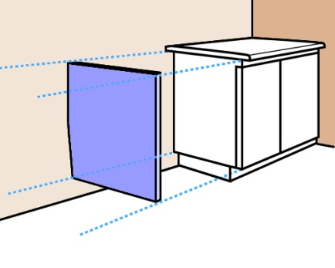This task deals with two scenarios where a vanity cabinet is being installed in the corner of a bathroom. In both instances the rear wall is out of plumb, but in opposite directions.

You have decided to hide the tapered gap between the cabinet and wall by fitting an end panel (the blue panel shown in the diagram at right).

The end panel will go from the underside of the bench top to the bottom of the cabinet, above the kickboard. It will fit hard against the wall and finish flush with the front of the door. Although the wall is out of plumb, it is flat, so the tapered side of the end panel will form a straight line and won’t need to be scribed.

You take the following measurements relating to the cabinet, and produce a quick detail drawing of each scenario (as shown in the diagrams on the next page).

* Bench top thickness: 35 mm
* Height from top of kickboard to top of bench top: 765 mm
* Width of cabinet (including door): 450 mm
* Bench top overhang: 25 mm

For each scenario:

1. draw the shape of the end panel in the blank space beside the detail drawing
2. mark in the width of the panel at the top, width at the bottom, and height
3. mark the two corners that are at right angles.

**Scenario 1**

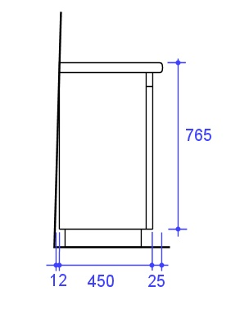

**Scenario 2**

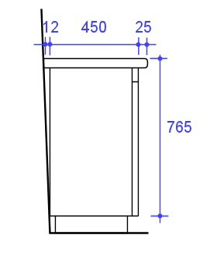

### Task 2: Power tools

This Task is designed to help you to prepare for your practical assessment event, where you will be asked to demonstrate your ability to re-cut or shape a panel using one or more power tools. The tools you’re likely to use will be an electric plane and a jig saw.

Choose either the plane or the jig saw and write up a brief safe operating procedure (SOP). See the sample SOP on the following page for an example of a completed SOP. This one is for a circular saw, so there are many similarities to the electric plane and jigsaw.

Use the template provided to write up your own SOP. You could look at the manufacturer's instruction booklet for more guidance or ask your supervisor for help.

**Sample SOP: Circular Saw**

### Potential hazards and safety controls

|  |  |
| --- | --- |
| Hazard | Control |
| Eye injuries | Wear safety glasses while using or standing near saw. |
| Hand and body injuries | Secure the material firmly before starting the saw.  Cut with a straight, even motion – do not twist the saw in the cut.  Always keep hands well clear of the blade.  Lift the saw clear of the cut before releasing the trigger.  Always stand to one side of the saw – not behind it.  Maintain a correct stance and cut with even motion.  Do not attempt to make cuts that are not appropriate for the saw. |
| Back injuries | Use good lifting practices when handling timber.  Move your feet when turning to avoid twisting your body. |
| **Noise** | Wear hearing protection when using or standing near the saw. |

### Pre-start checks

Check that:

* + saw blade is sharp and in good condition,
  + electrical lead and extension lead are in good condition,
  + guard is sound and retracts and springs back properly,
  + base plate is adjusted correctly for depth and angle of cut,
  + saw starts up and runs normally, without any unusual noises or vibrations.

### Operational procedure

* 1. Secure the material to be cut so that it cannot move.
  2. Position feet to give a comfortable balance and rest the base plate of the saw in position.
  3. Start the saw and allow it to reach full speed before commencing the cut.
  4. Push the saw smoothly and continuously through the cut, allowing the blade to come out the other side before releasing the trigger. Keep power lead clear of the saw path.
  5. Secure any large offcuts before they are allowed to break or snap off.

**SOP for:**

### Potential hazards and safety controls

|  |  |
| --- | --- |
| Hazard | Control |
|  |  |
|  |  |
|  |  |
|  |  |

### Pre-start checks

|  |
| --- |
|  |

### Operational procedure

|  |
| --- |
|  |